Gov
Alert

Supervisor
Dr. Mohammad Abushariah
Produced by

Name | ID
Rahmah Al-Omari | 2221790
Mera Daas | 2213066
Toqa Al-Rthoom | 0224255
Areen Al-Bqoor | 2220287
Rami Al-Shara | 0190863

Table of Contents
1.0 Project Initialization 5
1.1 Project Overview 5
1.2 Problem Definition 5
1.2.1 Problem Statement 5
1.2.2 Issues 5
1.2.3 Objectives 5
1.2.4 Requirements 6
1.2.5 Constraints 6
1.3 Feasibility Study 7
1.3.1 Technical Feasibility 7
1.3.2 Operational Feasibility 7
1.3.3 Economic Feasibility 7
1.3.4 Schedule Feasibility 8
1.3.5 Legal visibility 9
1.4 Local and Global Impact 9
1.5 Naming Conventions and Definitions 9
2.0 Project Management Plan 11
2.1 Project Organization 11
2.2 Roles & Responsibilities 11
2.3 Process Model 11
2.4 Tools and Techniques 11
3.0 Software Requirements Document 12
3.1 System Stakeholders and Requirement Sources 12
3.1.1 System Stakeholders 12
3.1.2 Sources of Requirements 12
3.2 User Requirement Definition 12
3.2.1 Citizens' Requirements 12
3.2.2 Government Department Staff Requirements 13
3.3 Use-case Models 13
3.4 System Functional Requirement Specification 14
3.4.1 Citizen Processes 14
3.4.2 Government Department Staff Processes 15
3.4.4 Functional Requirements Table 16
3.4.4 Requirements Scenarios 16
3.5 Textual Description for Each Use Case 19
3.5.1 Citizen 19
3.5.2 Government Department Staff Processes 19
3.6 Non-Functional Requirements 20
3.7 Data Requirements 21
4.0 Analysis and Design 23
4.1 Activity Diagram 23
4.1.1 Citizen 23
4.1.2 Government department 27
4.2 Sequence Diagrams 31
4.3 Class Diagram 32
4.4 Architecture Design - Context diagram 32
4.6 Graphical User Interface (GUI): 34
4.6.1 Desktop UI design (Eng): 34
4.6.2 Graphical Admin (UI): 40
4.7 Object to ER Mapping 43
5.0 Implementation 43
5.1 Graphical User Interface Implementation 43
5.1.1 Citizen 43
5.1.2 Government Department 54
5.2 Database Implementation 57
6.0 User Manual 59
7.0 References 65

Table 1: Development Costs 7
Table 2: Hardware & Software 7
Table 3: Project Schedule 7
Table 4:System Stakeholders and Requirement Sources 11
Table 5: Non-Functional Requirements 19

Figure 1: Use Case Model – Citizen (User) 13
Figure 2: Use Case Model – Government Admin 13
Figure 3: Sequence Diagram – Register Account 31
Figure 4: Sequence Diagram – Login 31
Figure 5: Sequence Diagram – Submit Report 31
Figure 6: Sequence Diagram – Notification for Status Update 32
Figure 7:Class Diagram 32
Figure 8: Context Diagram 33
Figure 9: ERD Mapping 43
Figure 10 User table 57
Figure 11 government department table 57
Figure 12 Report table 58
Figure 13 Chat table 58

Project Initialization

Project Overview
Modern cities and growing populations make it increasingly difficult for governments to maintain transparent, efficient, and responsive communication with their citizens regarding public services.
Citizens frequently encounter issues such as potholes, broken streetlights, public safety concerns, or sanitation problems. Traditionally, reporting these problems requires visiting government offices, calling hotlines, or sending emails methods that are time-consuming and inefficient.
GovAlert is a web application designed to solve this issue by providing a digital platform through which citizens can report public service problems directly to the appropriate government departments. With support for multiple languages, media uploads (such as photos), and real-time tracking of complaint status, GovAlert will improve service quality, increase transparency, and promote civic engagement.

Problem Definition

Problem Statement
Despite advances in digital services, many municipalities still rely on fragmented or outdated systems to handle public service complaints.
These systems often:
- Lack transparency.
- Provide no real-time feedback or status updates.
- Are not easily accessible to non-tech users or those speaking different languages.
Moreover, citizens often do not know whether their issue was received, acted upon, or ignored, leading mistrust. Government agencies also face difficulties in efficiently managing and routing incoming reports, resulting in delays and resource misallocation.

Issues
- No centralized or easy method to report issues to local authorities.
- Lack of visibility into report status after submission.
- No notification mechanism to update users about any progress.
- Reports are not prioritized by urgency or impact.
- Language barriers limit accessibility for all citizens.
- Weak citizen engagement and mistrust in public service responsiveness.

Objectives
Our project GovAlert aims to:
- Provide an accessible and intuitive mobile app for issue reporting.
- Enable users to submit reports using descriptions, images, and GPS data.
- Automatically classify and route issues to relevant government departments.
- Track and notify users about report progress and resolution status.
- Allow severity or urgency tagging of issues.
- Support multiple languages for broader accessibility.
- Encourage transparency and trust through visible complaint tracking.
- Enable citizens to rate and comment on government responses.

Requirements
For Users (Citizens):
- The user shall be able to access the home page.
- The user shall be able to sign up and log in securely.
- The user shall be able to submit complaints using the "Report Issue" feature.
- The user shall be able to upload images or videos with the Report.
- The user shall be able to use GPS to locate the issue location.
- The user shall be able to track the status of their Report.
- The user shall be able to view submitted complaints in "My Reports".
- The user shall be able to switch between Arabic and English.

For Admins (Gov Employees):
- The admin shall be able to log in and select their department.
- The admin shall be able to view complaints assigned to their department.
- The admin shall be able to accept or reject complaints.
- The admin shall be able to communicate with users via the complaint section.
- The admin shall be able to view full complaint details.

Constraints

1. Security and Privacy Requirements
2. Government System Understanding
3. Real-Time Tracking and Notifications
4. Accessibility and Ease of Use
5. Cross-Platform Development
6. Multilingual Support
7. Ongoing Maintenance

Feasibility Study

Technical Feasibility
GovAlert is a Brower-based application, designed to run on Android, iOS and Web-browsers. The system use available technologies such as HTML, CSS and JavaScript for frontend development, Node.js and MySQL for backend services including authentication, real-time communication and storage.
Resources required for this project include:
- Development workstations (laptops or desktops).
- Access to HTML, CSS and JavaScript.
- MySQL tools and Google Cloud services.
- Design and prototyping tools (Figma).
- Google Maps API (for location tagging).
All technologies used are either open source or available under free developer plans, making the solution cost-effective. The system is scalable, secure, and easy to maintain. Development teams are familiar with the chosen technologies, ensuring smooth implementation. The application can be deployed across devices running modern Android, IOS and Web which are hosted on online server. The system is considered technically feasible.

Operational Feasibility
GovAlert is operationally feasible as it directly addresses existing inefficiencies in public service communication. The app provides citizens with a streamlined and centralized platform to report problems, which improves user satisfaction and engagement. Government departments benefit from receiving categorized, geolocated reports that are easier to manage and prioritize.
The app’s real-time features as notifications and status updates enhance responsiveness, helping citizens feel heard and informed. The inclusion of urgency tagging helps departments handle issues faster, improving the public's perception of government efficiency.
Since the application is designed to be multilingual and intuitive, it is accessible to a wide range of users, including those with limited technical experience or different language backgrounds. The app will be tested with both stakeholders during development, using Agile methodology to ensure continuous improvement and usability.

Economic Feasibility

Development Costs
Table 1: Development Costs
Role | Cost/Hour (JOD) | Total Hours | Total Cost (JOD)
2 Mobile Developers | 22 | 500 | 22,000
1 Backend Engineer | 25 | 320 | 8,000
1 UI/UX Designer | 20 | 150 | 3,000
1 Project Manager | 30 | 100 | 3,000
1 QA Tester | 18 | 160 | 2,880
Total Personnel Cost |  |  | 38,880

Hardware & Software
Table 2: Hardware & Software
Item | Cost (JOD)
2 Development Laptops | 3,000
MySQL Usage Plan | 500 (est.)
Figma Premium | 150
Domain Name & Hosting | 200
Total Hardware/Software | 3,850

Total Development Cost: 42,730 JOD
Operating Cost (Annual): ~3,000 JOD (support, updates, cloud services)

Schedule Feasibility
Table 3: Project Schedule
Task | Description | Start Time | Duration (Days) | Dependency
1 | Project Planning & Requirement Analysis | 28/03/2025 | 6 | NONE
2 | Feasibility Study & Documentation | 02/04/2025 | 8 | Task 1
3 | UI/UX Prototyping | 09/04/2025 | 9 | Task 2
4 | Frontend Development | 17/04/2025 | 12 | Task 3
5 | System Integration & Backend Communication | 28/04/2025 | 10 | Task 3
6 | Testing and Debugging | 07/05/2025 | 7 | Task 4,5
7 | Final Report & User Manual Preparation | 13/05/2025 | 8 | Task 6
8 | Presentation Preparation | 20/05/2025 | 5 | Task 7

- The expected tasks should be done in total duration around (65) days.
- The start event: T1 (Project Planning).
- The end event: T8 (Presentation Preparation).
- Critical path Tasks are: T1, T2, T3, T4, T6, T7, T8.
- Critical path length is: 65 days.
Project Timeline PERT chart
T1

T6

T4

T3

T2

10d

12d

5d

8d

7d

9d

8d

6d

Start

T7

T8

End
T5
/

Legal visibility
The GovAlert application complies with local digital governance regulations, privacy protection policies, and data confidentiality laws. All data stored and transmitted will be encrypted, and sensitive user information will be handled in accordance with best practices for the application security and standards.

Local and Global Impact
Local Impact:
GovAlert improves civic responsiveness and issue resolution by enabling real-time, two-way communication between citizens and government departments.
Global Impact:
The system can be adapted for use by municipalities worldwide, aligning with smart city initiatives.

Naming Conventions and Definitions
Citizen/User – A resident who uses the GovAlert app to report public issues
Admin – Government employee who reviews and resolves reported issues
Urgency Level – Priority tag: Low, Medium, or High
Status – Issue lifecycle stage: Pending, In Progress, or Resolved
Report ID – Unique identifier for each issue
Feedback – User rating and comments post-resolution

Project Management Plan

Project Organization
To ensure the project stays on track, the team will conduct weekly meetings to assess progress, allocate tasks, and resolve any issues that arise. Tasks will be assigned according to each team member's skills and availability. Additionally, time will be set aside during these meetings for brainstorming sessions and creative problem-solving to foster innovative solutions.

Roles & Responsibilities
- Project Manager (Rahmah Al-Omari): Oversees planning, resource allocation, Coordinates with the team to ensure the project aligns with the team's goals and vision, risk management, and ensures deadlines are met.
- Frontend Developers (Mera Daas, Rami Al-Shara): Design user-facing interfaces.
- Backend Engineer (Areen Al-Bqoor): Manages server, database, and API integration.
- UI/UX Designer (Toqa Al-Rthoom): Designs app flow, user journeys, and accessibility.
- QA Tester (All members): Conducts manual testing, feedback collection, and defect reporting.

Process Model

The team will follow the Agile methodology with iterative development and stakeholder and feedback cycles with the flexibility to adapt to changing requirements.
Work Breakdown Structure: Requirement Gathering, UI/UX Design, Frontend Development, Backend APIs, Notifications and Real-Time Sync, Testing and Feedback, Deployment
Monitoring & Control: Weekly stand-ups, GitHub/Trello tracking, milestone reviews, final user testing.

Tools and Techniques
The following tools and techniques are utilized for the development, management, and collaboration of the GovAlert system:
Figma: For creating interactive prototypes and designing user interfaces.
Visual Studio Code: For coding and developing the front-end (HTML, CSS, JavaScript) and back-end (Node.js) components, with support for debugging and version control.
MySQL: Database management system for handling and storing complaint data, user profiles, and activity logs.
Google Meet and WhatsApp: For team communication, collaboration, and conducting weekly meetings.

Software Requirements Document

System Stakeholders and Requirement Sources

System Stakeholders
Table 4:System Stakeholders and Requirement Sources
Stakeholder | Description | Requirement Sources
Citizens | Report issues, receive updates, provide feedback | Surveys, Reports
Government Departments | Manage and resolve issues | Meetings, Response
Developers | Build and maintain system | Agile backlog

Sources of Requirements

Interviews :
With citizens and government officials to identify areas of misery in current public service reporting procedures and collect desired functionalities.

Analysis of Existing Systems:
Compared current manual and electronic complaint systems used by municipalities to identify inefficiencies and gaps.

User Requirement Definition

This defines the features the GovAlert system must provide to serve the interests of its key stakeholders: employees in government departments and citizens. The features shall be made available by the system securely, accessibly, and easily utilized.

3.2.1 Citizens' Requirements

3.2.1.1 Registration and Login:
There must be a registration facility through email, full name, phone number, and a secure password, and then login capacity to utilize services.
Personal information must be saved in a secure encrypted manner and only used for complaint processing and communication.

3.2.1.2 Report Submission:
The citizen must be provided with the ability to submit complaints, including issue type (e.g., Road, Electricity), written description, GPS-based location, and optional photo/video attachments.

3.2.1.3 Report Viewing:
The citizen must be able to view their submitted complaint current status (Pending, In Progress, Resolved) along with time-stamped remarks and department assigned information in the "My Reports" section.

3.2.2 Government Department Staff Requirements

3.2.2.1 View Assigned Complaints:
Staff members must be able to see a secure admin interface with complaints allocated to their department, listed by date, urgency, type of issue, or status.

3.2.2.2 Update Complaint Status:
Staff must be able to change complaint status (e.g., Pending, In Progress, Resolved, Rejected), internal comments, and reply to citizens via comments on the complaint.

Use-case Models

Use Case Model – Citizen (User)
Figure 1: Use Case Model – Citizen (User)
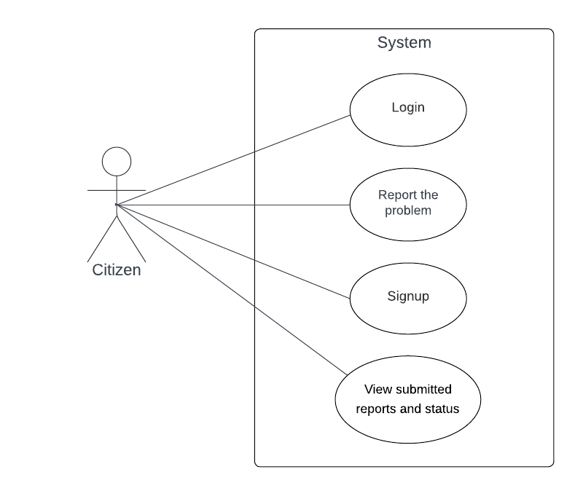

Use Case Model – Government Admin
Figure 2: Use Case Model – Government Admin
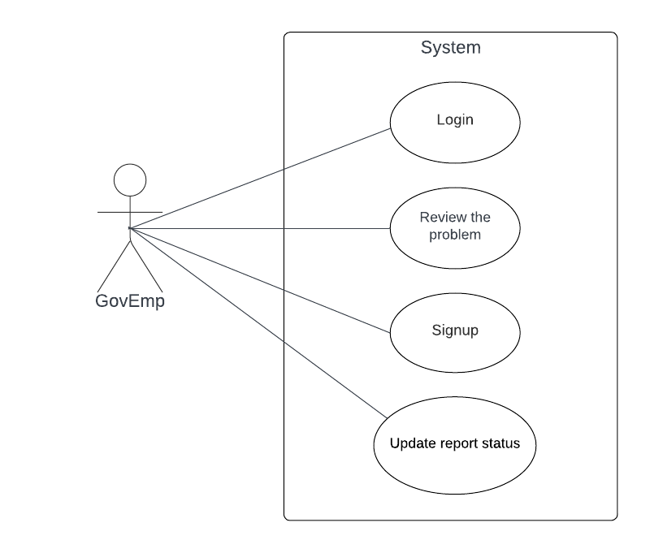

System Functional Requirement Specification

Citizen Processes

Log In

- Open the GovAlert web interface.
- Navigate from the homepage to the "Log In" page.
- Provide a valid phone number or e-mail address and password in the appropriate fields.
- Click the "Log In" button.
- The credentials are verified by the system against the database.
- When credentials are valid, the user is redirected to the main dashboard of the app.
- When credentials are not valid, an error message (e.g., "Invalid email or password") is displayed along with a request to try again or use the "Forgot Password" feature.

Sign Up

- Open the GovAlert web interface.
- Navigate the "Sign Up" page from the home page.
- Provide full name, email, phone number, password.
- Click on the "Sign Up" button.
- System verifies inputs (e.g., email format, password strength, distinct email/phone).
- If verification fails, an error message shows missing or incorrect fields (e.g., "Email already taken").
- If verification is successful, the system registers the account and sends a verification email.
- The user clicks the link from the verification email to activate the account.
- The user is prompted to sign in using the new credentials.

Report the Problem

- Log in to the GovAlert app or web portal.
- Navigate to the "Report Issue" tab from the dashboard.
- Select the issue type from a dropdown menu (Road, Electricity, Sanitation, etc.).
- Enter a brief title and a complete description of the issue.
- upload a photo or video to support the complaint (optional).
- Allow GPS permission for automatic location capture of the issue or manually enter the address.
- Select an urgency level (Low, Medium, High).
- Click on the "Submit Complaint" button.
- The system checks all the required fields and saves the complaint in the database with a distinct Report ID.
- The complaint is directed to the appropriate government agency, and the user gets a confirmation message.

View Submitted Reports & Status
- Login to the GovAlert app or web portal.
- Navigate to the "My Reports" section from the home dashboard.
- View a list of all complaints received, with Complaint ID, title, received date, status (Pending, In Progress, Resolved), and department assigned.
- View an individual complaint to view detailed information, like description, attached media, urgency level, and time-stamped history of status.
- The status is updated in real-time based on actions by government staff.

3.4.2 Government Department Staff Processes

3.4.2.1 Log In

- Open the GovAlert admin web portal.
- Access the "Log In" page.
- Enter a valid email address or username, password, and select the department from a drop-down list.
- Click on "Log In".
- The system validates the credentials against the database.
- If the credentials are valid, the staff member is redirected to the department admin dashboard.
- If the credentials are not valid, an error message (e.g., "Invalid credentials") is displayed, requesting to retry or reset password.

3.4.2.2 Sign Up

- Open the GovAlert admin web portal.
- Go to the "Sign Up" page.
- Enter email address, username, full name, password, and select department.
- Click the "Sign Up" button.
- System verifies inputs (i.e., email validity, unused username/email, password strength).
- In the event of failure in validation, error message directs to wrong fields (e.g., "Username already in use").
- On successful validation, the system creates account and perhaps sends it for municipal authority approval (optional).
- On approval, the staff member receives e-mail confirmation and can log in.

3.4.2.3 Review the Problem
- Login to GovAlert admin dashboard.
- Go to the "Complaints" page, displaying all the complaints assigned to the staff department.
- Apply filters (e.g., date, urgency, type of issue, status) to filter the list if needed.
- Click on a specific complaint to view its details, e.g., Complaint ID, issue type, description, GPS location, media attached, urgency level, and submission time.
- See complaint details in order to assess the issue and determine what must be done (e.g., pass to a team, request clarification).

3.4.2.4 Update Report Status

- Log in to GovAlert admin dashboard.
- Navigate to the "Complaints" tab and select a complaint to edit.
- Check the complaint details to make sure the current status and context are accurate.
- Change the status by selecting one of the options (e.g., Pending, In Progress, Resolved, Rejected) from a dropdown menu.
- Include internal comments or a note, if needed, to speak with the citizen.
- Click the "Update Status" button.
- The system stores the updates, keeps a record of the update along with the timestamp, and pushes a message to the citizen for status change.

Functional Requirements Table

Requirement ID
Functional Requirement

FR-01
The system shall allow citizens to register and log in using an email or phone number and secure password.

FR-02
The system shall allow government staff to register and log in using an email or username, password, and department selection.

FR-03
Citizens will be provided with a templated form with mandatory fields (cf. issue type, description, location) and optional media.

FR-04
Citizens will be provided with the status of their complaint and update logs in "My Reports".

FR-05
Government officials will be able to view and filter complaints assigned to their department.

FR-06
Government officials will be able to modify the status of a complaint and enter comments and alert citizens.

FR-07
The system will have a bilingual interface (English and Arabic) for all the stakeholders.

FR-08
Citizens will be permitted to change their profile data (e.g., email, mobile number), with validated and encrypted input

Requirements Scenarios
This section describes realistic interaction scenarios that demonstrate how users and administrators will interact with the GovAlert system, including both standard flows and potential failure cases.

Scenario 1: User Access & Installation
Normal Flow:
The GovAlert app is available in both the Apple App Store and Google Play Store. A user can install the app and open it from their mobile device.
What Can Go Wrong:
- If the user has an outdated OS, the app may not be compatible.
- If there’s no internet connection, the app displays an error and suggests trying again.

Scenario 2: Account Registration
Normal Flow:
A new user opens the app, taps “Sign Up,” enters their details (name, email, phone, password), and successfully creates an account.
What Can Go Wrong:
- The email is already in use: the system shows a helpful error and offers password recovery.
- Weak password: the system asks for a stronger one.
- Missing fields: the system highlights the required fields.

Scenario 3: Login
Normal Flow:
A returning user enters their email and password and is taken to the home screen.
What Can Go Wrong:
- Typo in email/password: system displays “Invalid credentials” and allows retry.
- User is inactive for long: system auto-logs out and prompts re-authentication.

Scenario 4: Submitting a Public Issue
Normal Flow:
User selects “Report Issue,” fills in a title and description, attaches a photo, selects a category, and allows GPS to capture their location. The issue is submitted and stored in MySQL.
What Can Go Wrong:
- GPS permissions denied: user is prompted to manually enter the location.
- No internet: submission fails with retry option.

Scenario 5: Notification and Status Tracking
Normal Flow:
The municipality updates the report status to “In Progress.” The user receives a push notification and sees the new status in their report history.
What Can Go Wrong:
- Notification service fails temporarily: the user still sees updated status upon next app open.

Scenario 6: Submitting Feedback
Normal Flow:
After a report is marked “Resolved,” the user is prompted to rate the handling (1–5 stars) and add comments.
What Can Go Wrong:
- User skips feedback: the system logs this as “No Feedback Given” and still closes the report.
- Abusive comments: flagged for admin moderation.

Scenario 7: Admin Updates Report Status
Normal Flow:
A government staff member logs into the admin dashboard, filters reports by category, selects a complaint, and changes the status to “Resolved.”
What Can Go Wrong:
- Attempt to update a non-existent report ID: system returns “Error: Report Not Found.”
- Concurrent updates: the system uses timestamps to prevent conflict and overwrites.

Scenario 8: Scheduled Maintenance and Downtime
Normal Flow:
Scheduled backend maintenance is communicated via in-app banners. During downtime, users see a friendly message that service is temporarily unavailable.
What Can Go Wrong:
- If unscheduled downtime occurs, a failover message is displayed, and error logs are sent to developers.

Textual Description for Each Use Case

3.5.1 Citizen

3.5.1.1 Log In
Description: Allows citizens to log in to the GovAlert system securely using their credentials.
Actors: Citizen
Data: Email or phone number, password
Stimulus: Press "Log In" on the app or web interface
Response: Authenticates credentials and grants access or displays an error.
Comments: Encrypted personal data, and the email/phone number must be unique.

3.5.1.2 Sign Up
Description: Enables citizens to register a new account to view GovAlert services.
Actors: Citizen
Data: Full name, email address, phone number, password, preferred language
Stimulus: Press "Sign Up" on the app or web interface
Response: Input is verified, an account is signed up, and a sign-up email is sent.
Comment: Input data is validated, and sensitive information (e.g., password) is encrypted. Email/phone number must be unique.

3.5.1.3 Report the Problem
Description: Allows citizens to report a public service issue with supporting evidence.
Actors: Citizen
Data: Type of issue, description, photo (optional), location, level of urgency
Stimulus: Click "Report Issue" on the app or web portal
Response: Issue reported and referred to the concerned government department.
Comments: All except photos are mandatory fields; location captured automatically using GPS if permitted.

3.5.1.4 View Submitted Reports & Status
Description: Enables citizens to view filed complaints and track their status.
Actors: Citizen
Data: Complaint ID, date filed, status, assigned department
Stimulus: Navigate to "My Reports" section
Response: Displays a list of filed reports with status details and update history.
Comments: Status gets updated automatically after staff actions; timestamp is provided on the information.

3.5.2 Government Department Staff Processes

3.5.2.1 Log In
Description: Allows government employees to safely log in to the admin panel.
Actors: Government Department Employees
Data: Email or username, password, department selection
Stimulus: Press "Log In" on the admin web page
Response: The system verifies credentials and grants access to the department-specific panel.
Comments: Email/username is unique, and personal information is encrypted.

3.5.2.2 Sign Up
Description: Enables government employees to sign up to have access to the admin dashboard.
Actors: Government Department Employees
Data: Name, email, username, password, department
Stimulus: Click "Sign Up" at the admin web portal
Response: Inputs are checked for validity by the system, an account is registered, and departmental access is assigned.
Comments: Input data is checked, and sensitive data is encrypted. Accounts may require municipality approval.

3.5.2.3 Review the Problem
Description: Allows government staff to view and analyze complaints assigned to their department.
Actors: Staff working in the government department
Data: ID of complaint, type of issue, description, location, image (if uploaded)
Stimulus: Select a complaint from the admin dashboard
Response: Displays full complaint details to review and act upon.
Comments: Complaints can be filtered by status, urgency, type, or date.

3.5.2.4 Update Report Status
Description: Enables government officials to update the status of complaints and message citizens.
Actors: Government Department Personnel
Data: Complaint ID, new status, comments (optional)
Stimulus: Select complaint and update status from admin dashboard
Response: The system saves updates, records action and notifies the citizen.
Comments: Changes are timestamped and recorded for transparency.

Non-Functional Requirements
The non-functional requirements define the system’s quality attributes and operational standards.
Table 5: Non-Functional Requirements
 | Requirement Type | Requirement Description
1 | Usability | The system shall offer a clean and intuitive interface, requiring no more than 15 minutes of learning time for a first-time user.
2 | Accessibility | The application shall support multilingual interfaces (e.g., Arabic, English), large fonts, and basic screen reader compatibility.
3 | Performance | The system shall respond to user actions (e.g., report submission, status checking) within 2 seconds under normal load.
4 | Availability | The application shall be available 99.5% of the time annually, with the exception of scheduled maintenance windows.
5 | Security | All user data must be encrypted in transit (using HTTPS) and at rest. Passwords must be hashed securely.
6 | Scalability | The system shall be able to scale to support usage by multiple municipalities and thousands of concurrent users.
7 | Maintainability | The system codebase shall follow best practices and modular design to allow for easy updates, bug fixes, and upgrades.
8 | Portability | The mobile application shall support both Android (version 7.0+) and iOS (version 12+).
9 | Data Integrity | The system shall prevent unauthorized access, accidental data loss, and duplicate submissions using validation and transactional operations.
10 | Backup and Recovery | Automatic daily backups shall be performed, and the system must be recoverable within 24 hours after a critical failure.

Data Requirements

Entities and Data Fields

Reports:

Report ID (unique identifier)
Description (detailed explanation of the issue)
Issue Type (e.g., Road, Electricity, Sanitation, Public Safety)
Location (GPS coordinates or manually entered address)
Media (optional photo or video file path/URL)
Status (Pending, In Progress, Resolved, Rejected)
Submission Date (timestamp of complaint submission)
Citizen ID (link to citizen user details)
Department ID (link to assigned government department)
Comments (text for admin-citizen communication)

Citizens:

Citizen ID (unique identifier)
Full Name (user’s full name)
Email Address (unique, validated email)
Phone Number (unique, validated phone number)
Password (encrypted)

Government Staff:

Staff ID (unique identifier)
Full Name (staff member’s full name)
Email Address (unique, validated email)
Password (encrypted)
Department ID (link to department details)
Role (e.g., Admin, Reviewer, Manager)

Departments:

Department ID (unique identifier)
Department Name (e.g., Road Maintenance, Sanitation, Electricity)
Contact Email (department’s official email)
Phone Number (department’s contact number)
Description (brief overview of department responsibilities)

Analysis and Design

Activity Diagram

Citizen

Sign up
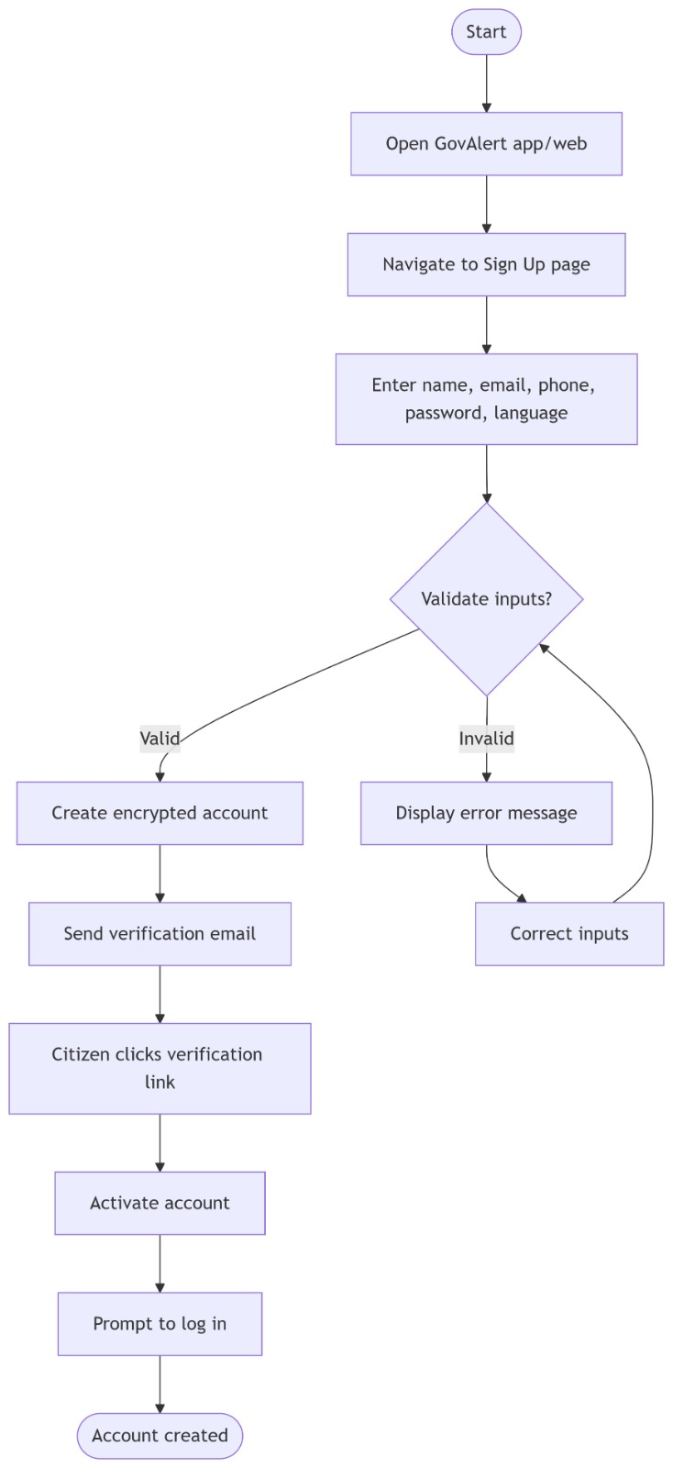

4.1.1.2 Log in
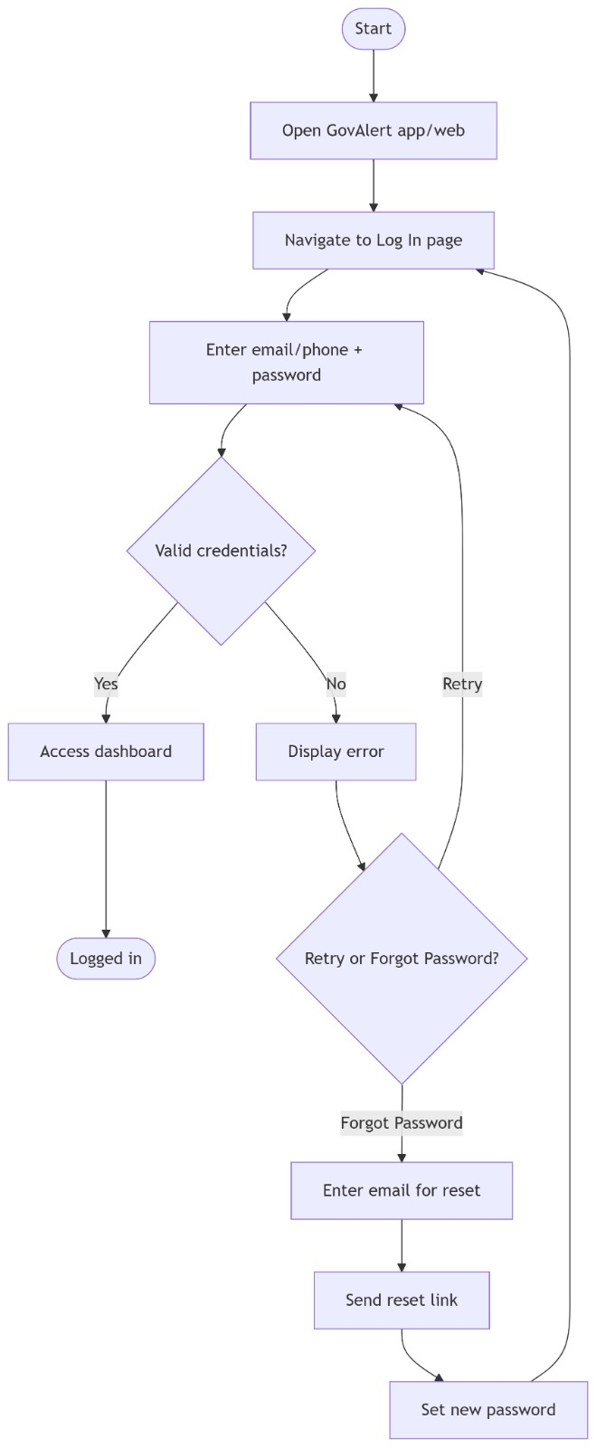

4.1.1.3 View report
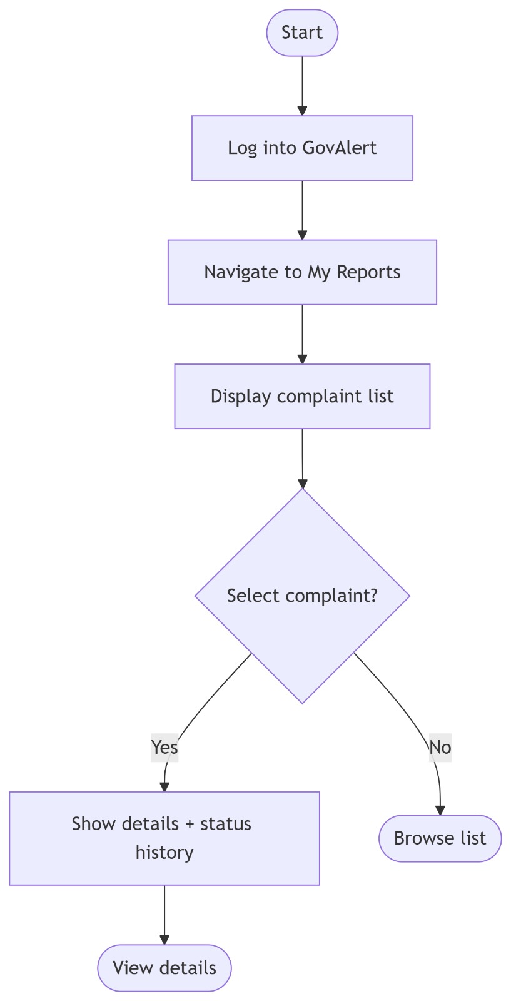

4.1.1.4 Report problem
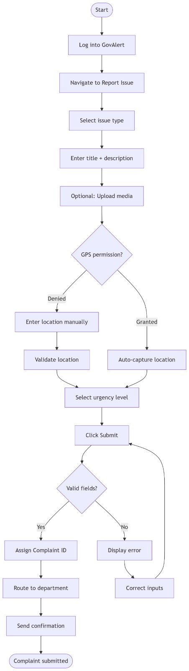

4.1.2 Government department

4.1.2.1 Sign up
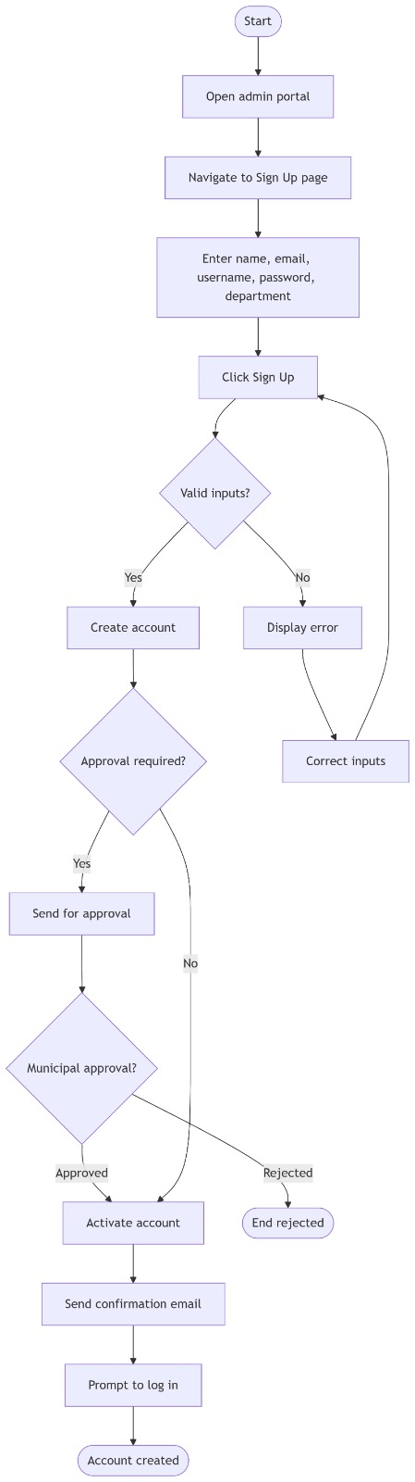

4.1.2.2 Log in
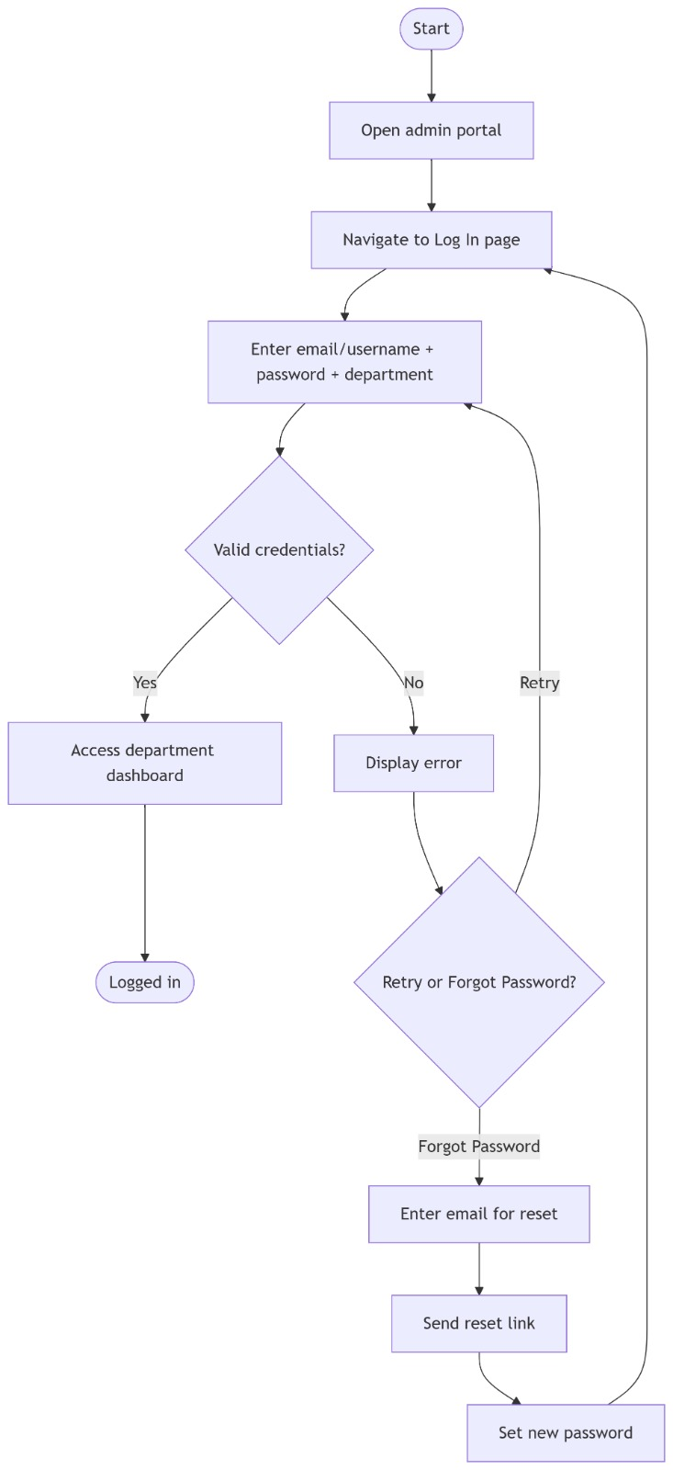

View report
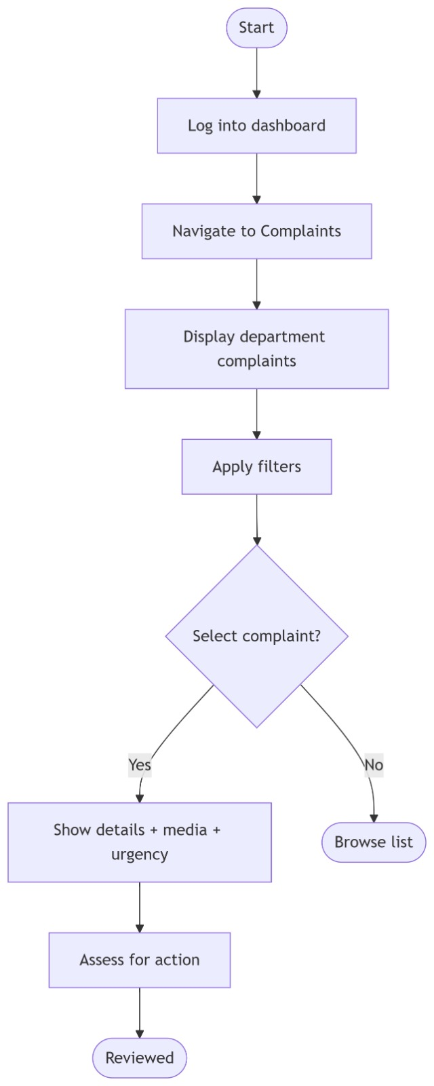

Update report status

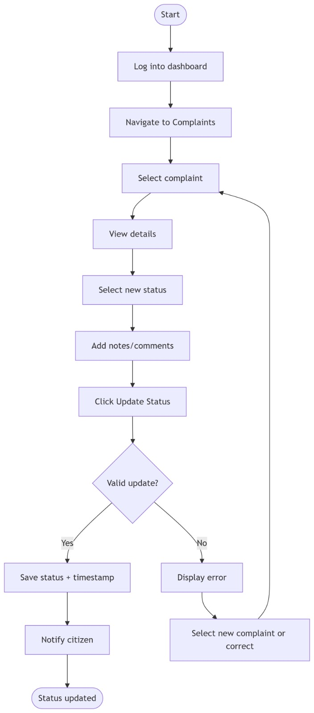

Sequence Diagrams

Sequence Diagram – Register Account
Figure 3: Sequence Diagram – Register Account
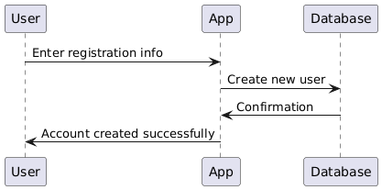

Sequence Diagram – Login
Figure 4: Sequence Diagram – Login
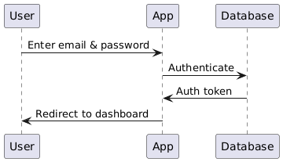

Sequence Diagram – Submit Report
Figure 5: Sequence Diagram – Submit Report
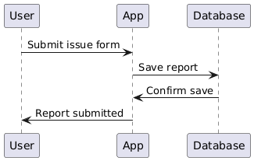

Sequence Diagram – Notification for Status Update
Figure 6: Sequence Diagram – Notification for Status Update
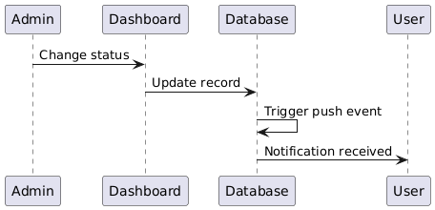

Class Diagram

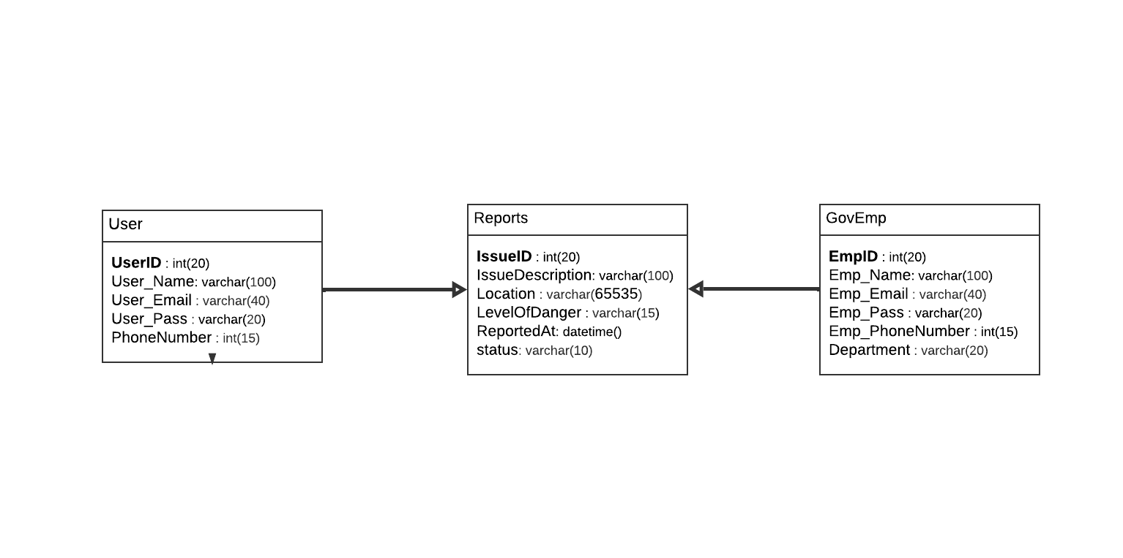
Figure 7:Class Diagram

Architecture Design - Context diagram
The context diagram represents the highest-level view of the GovAlert system. It shows how the system interacts with external entities such as citizens, government departments, and the admin portal.
Figure 8: Context Diagram
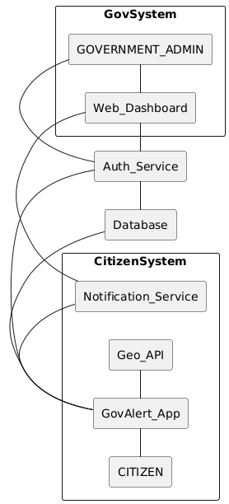

Graphical User Interface (GUI):

Desktop UI design (Eng):
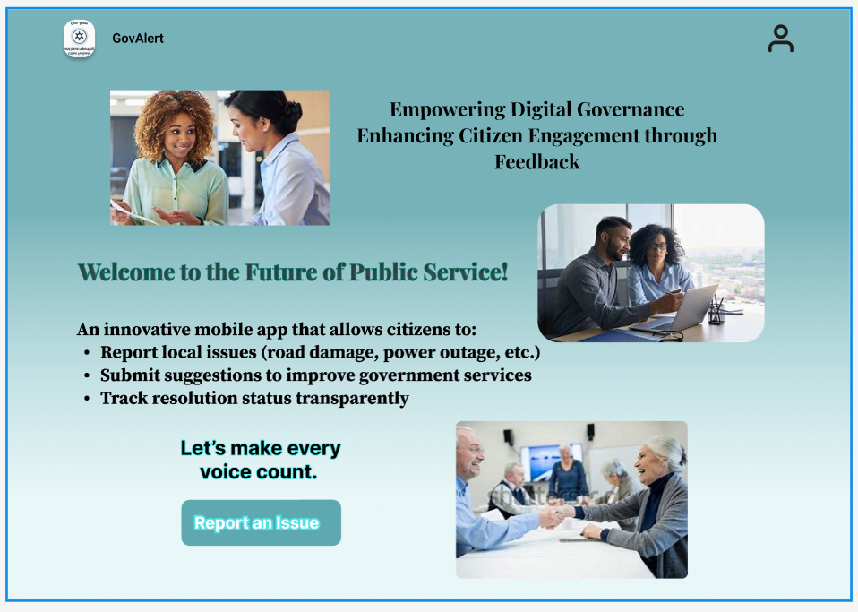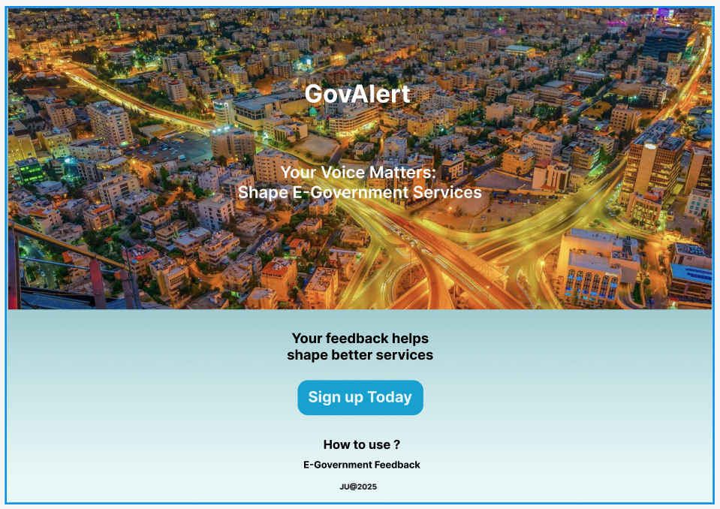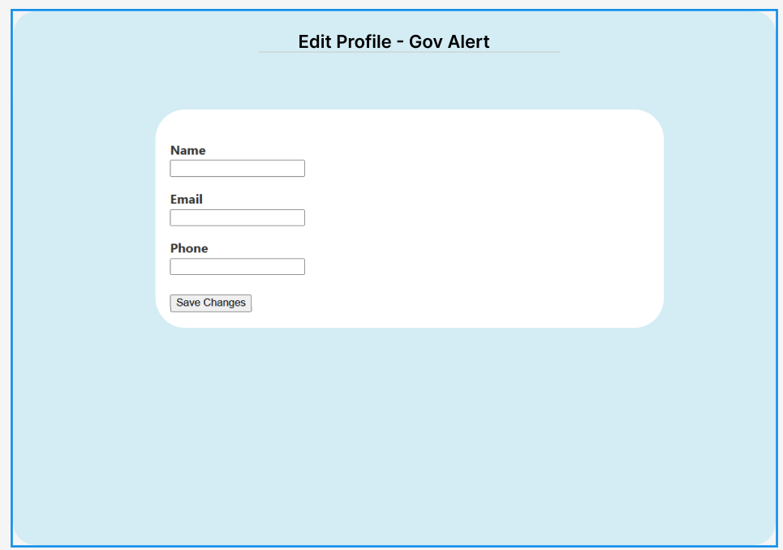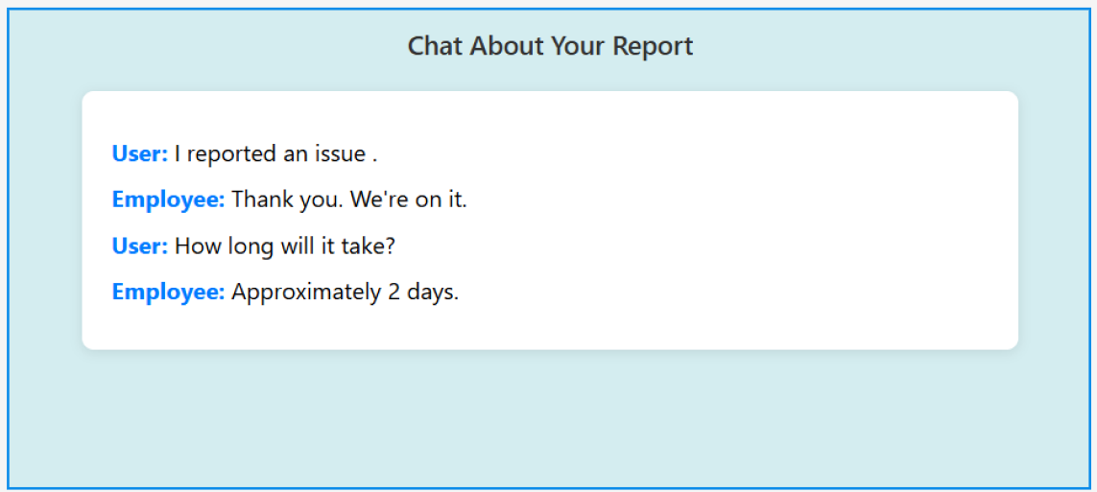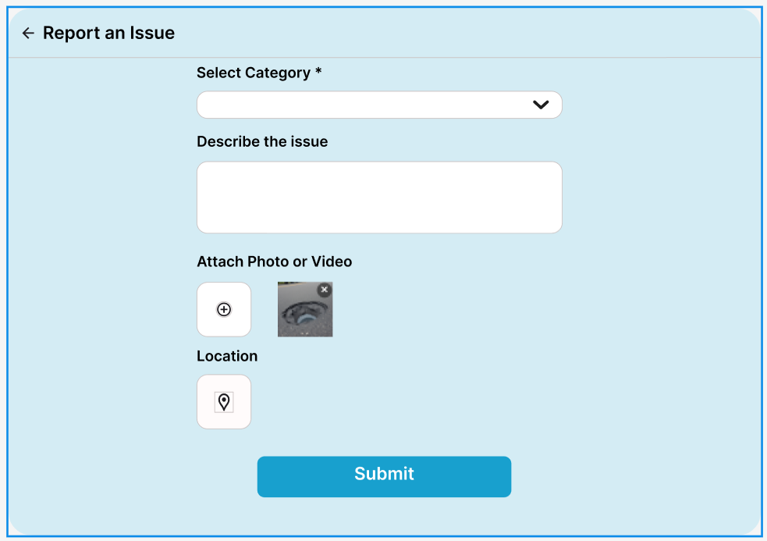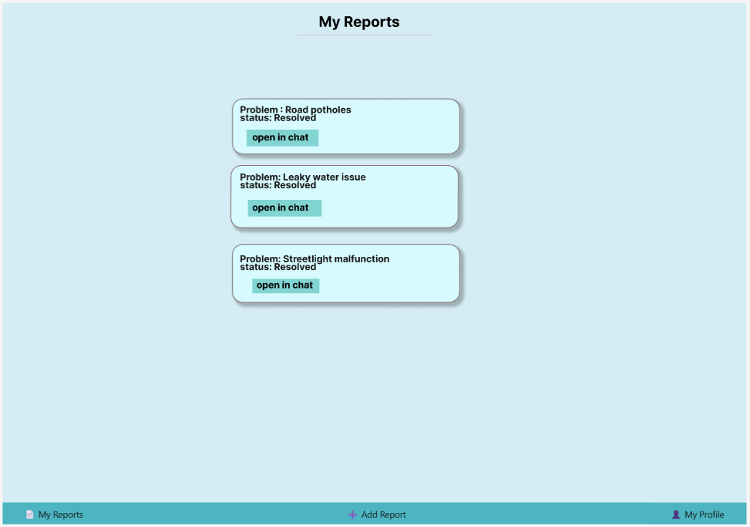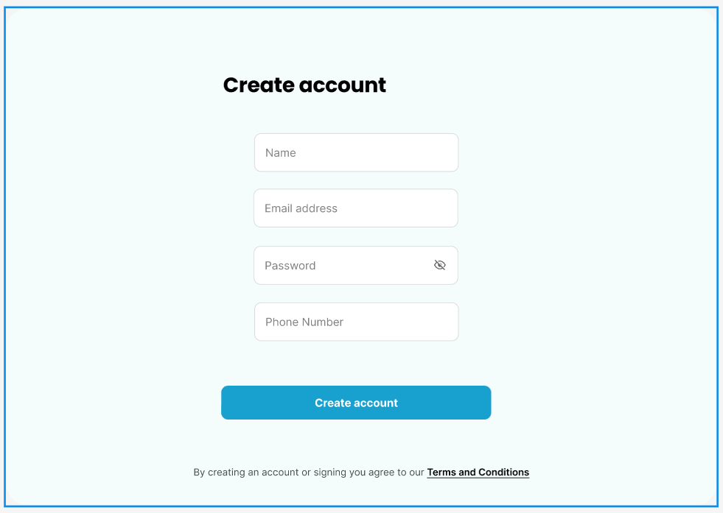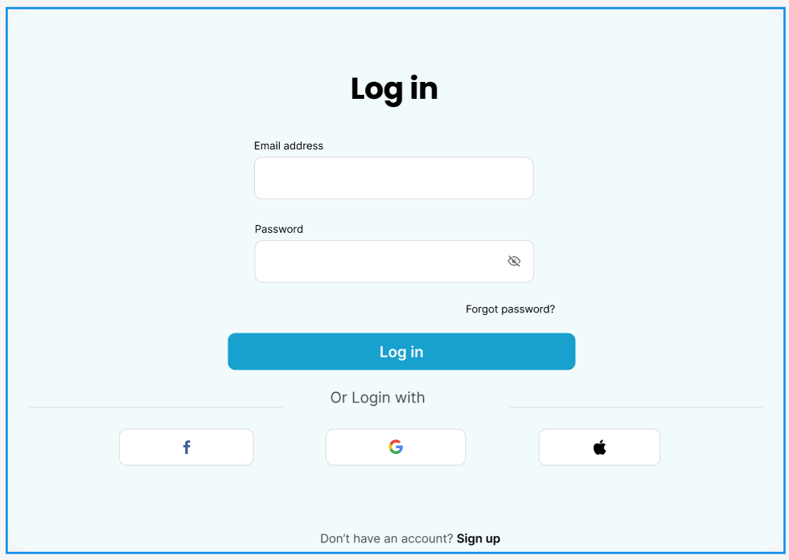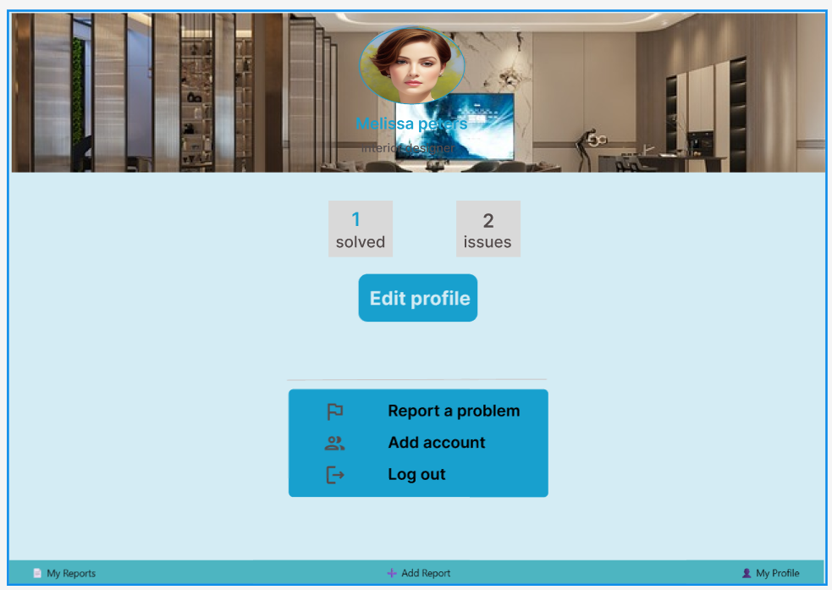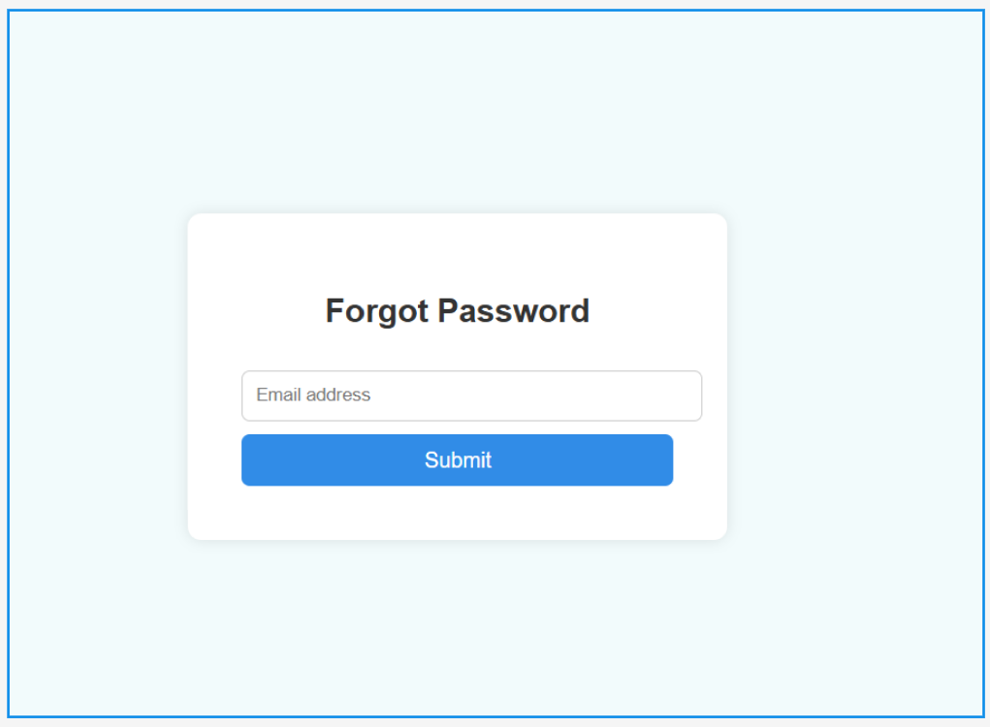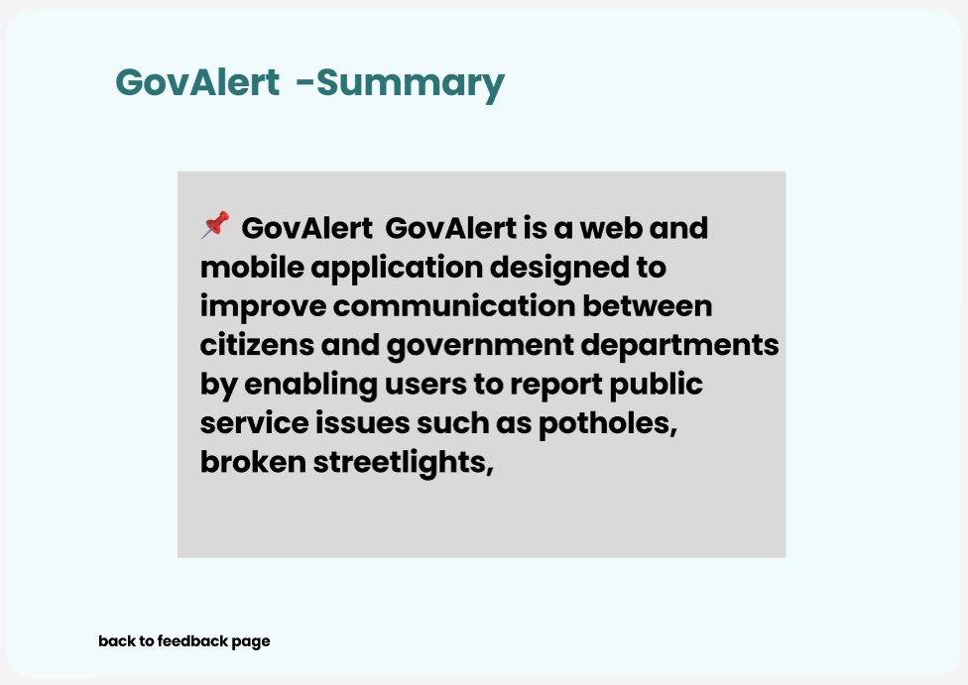

Graphical Admin (UI):
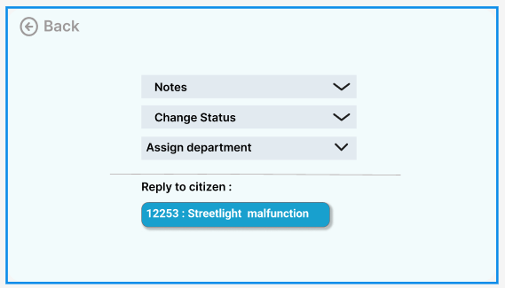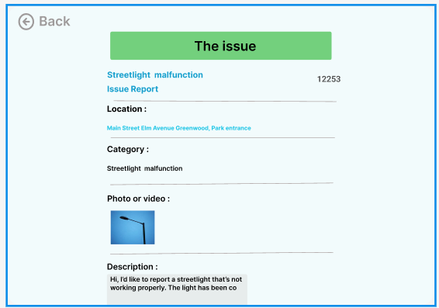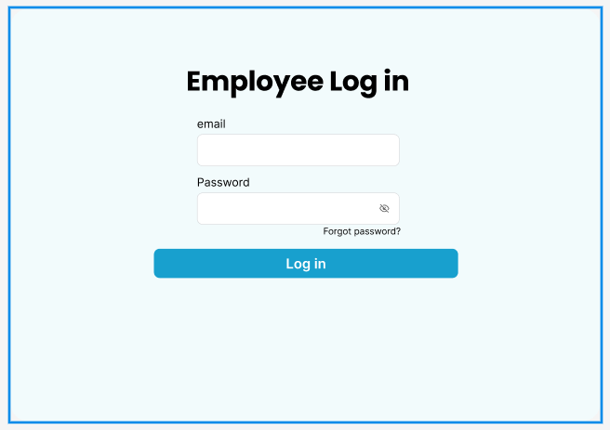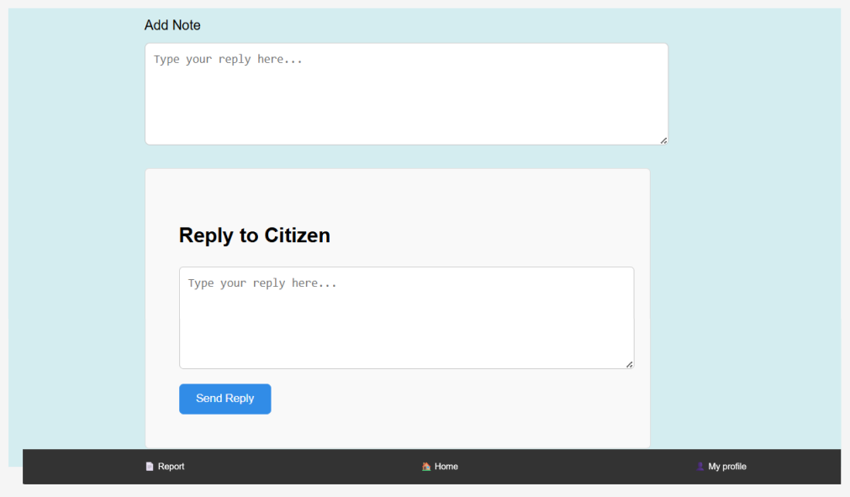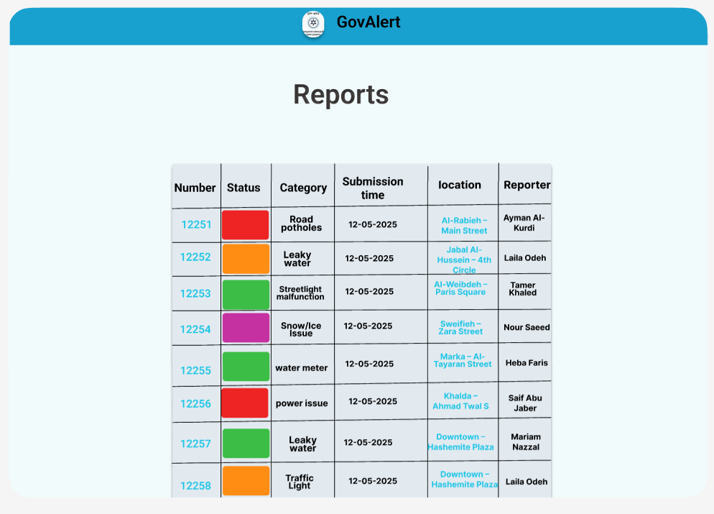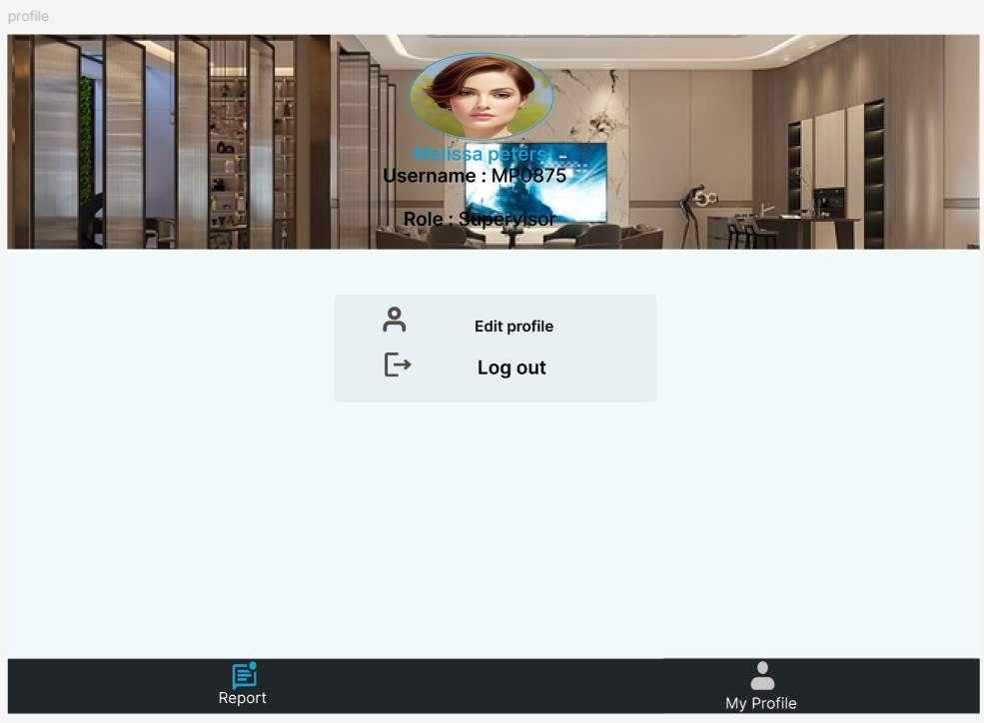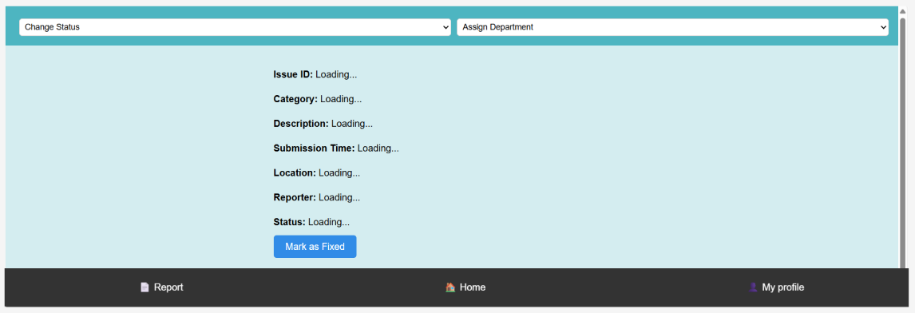

Object to ER Mapping
Figure 9: ERD Mapping
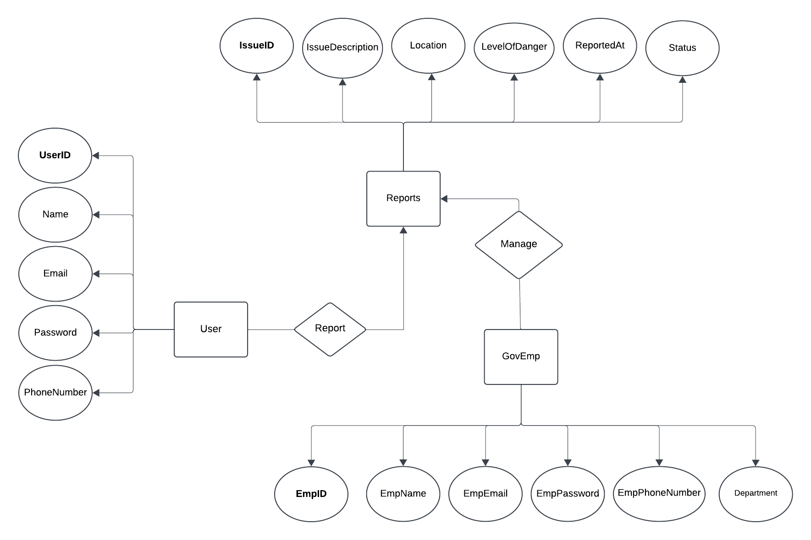

Implementation

Graphical User Interface Implementation

Citizen

welcome page

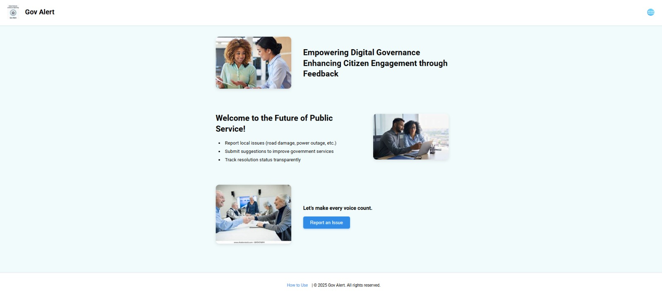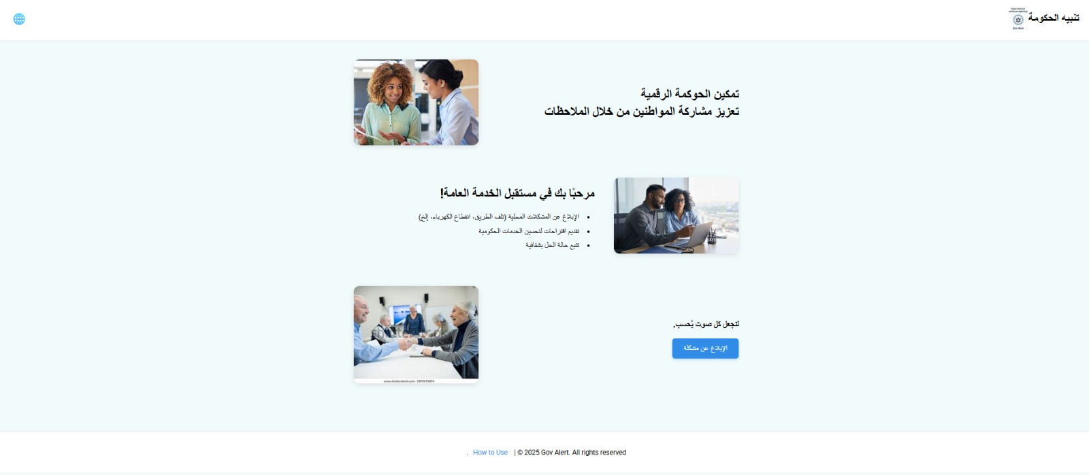

Feedback page

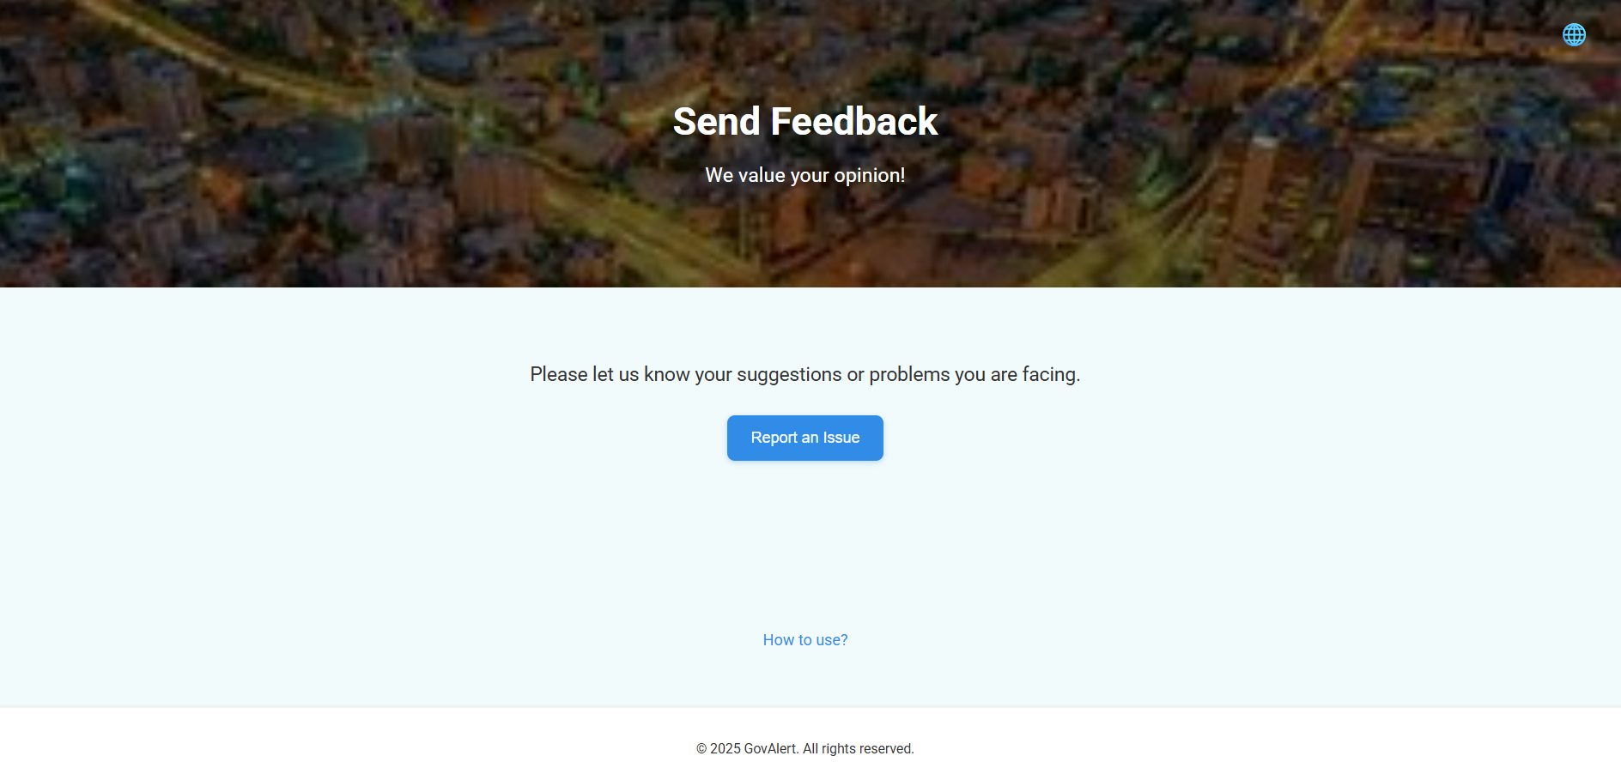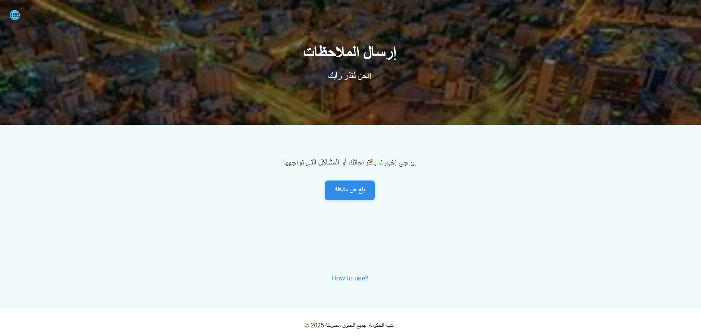

Manual base
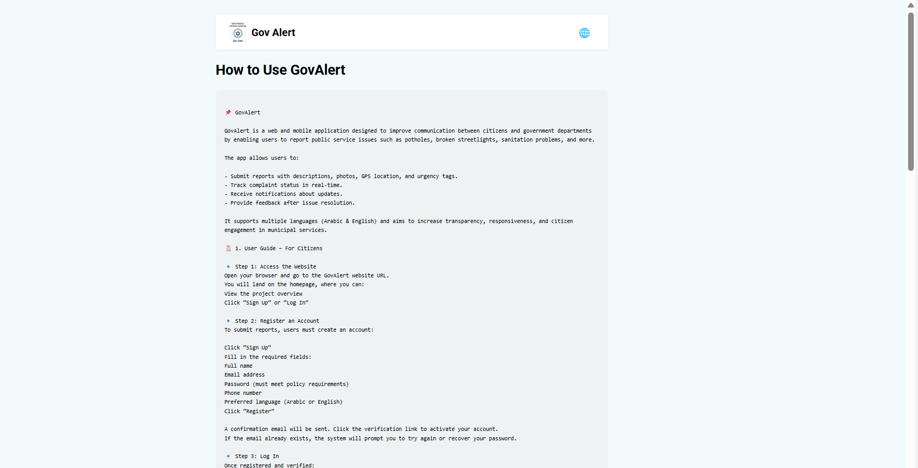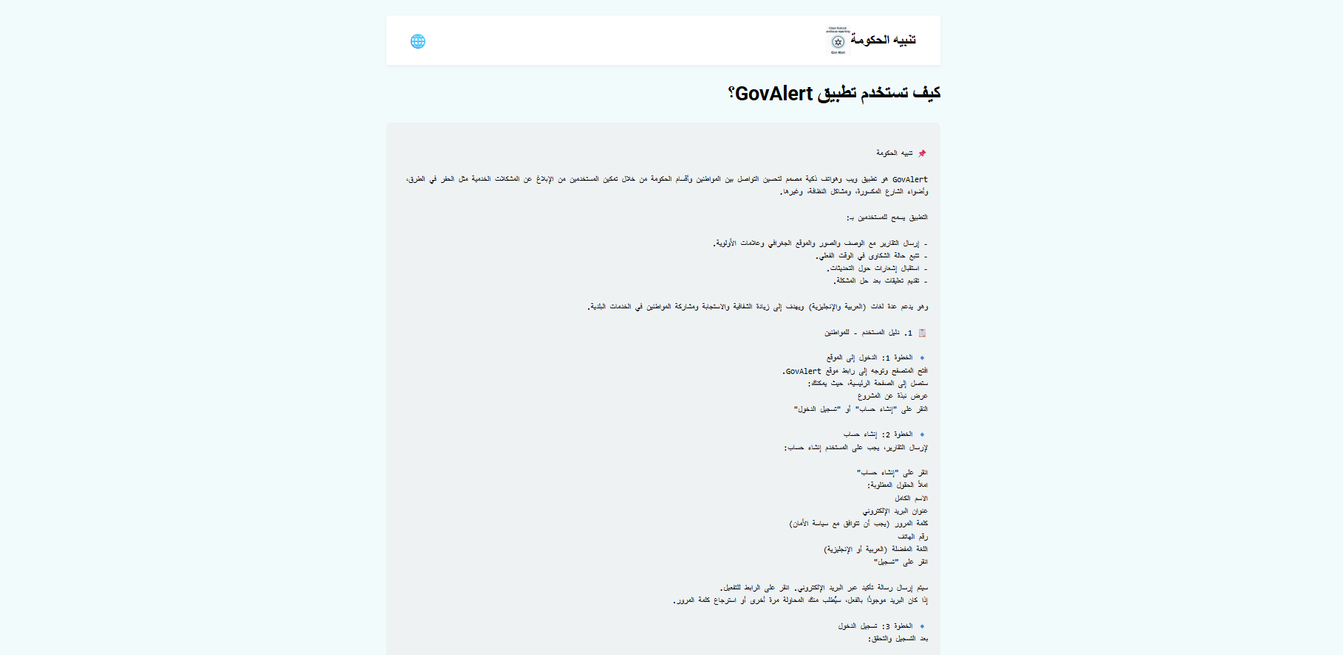

Log in
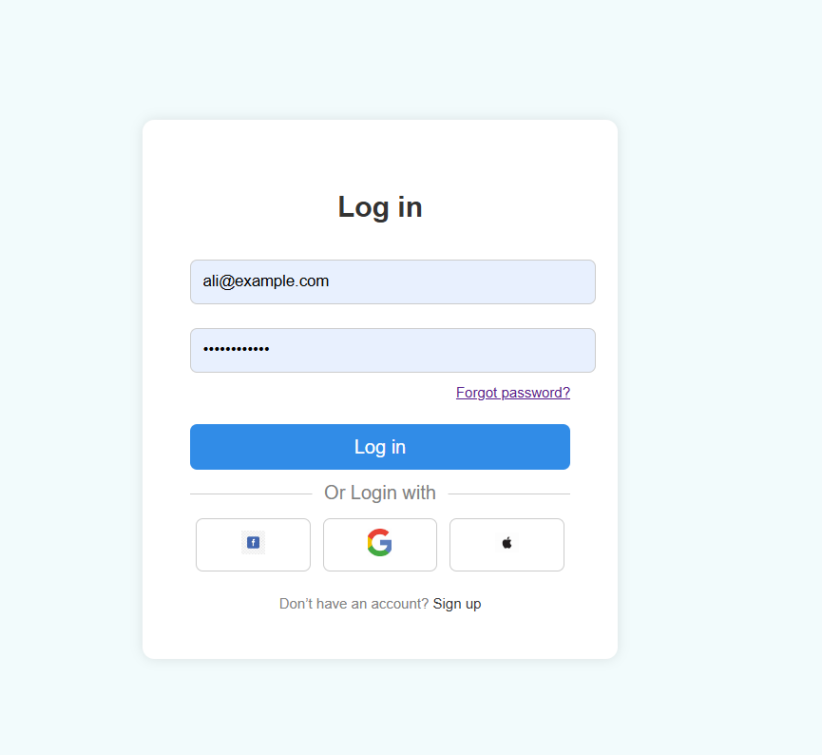
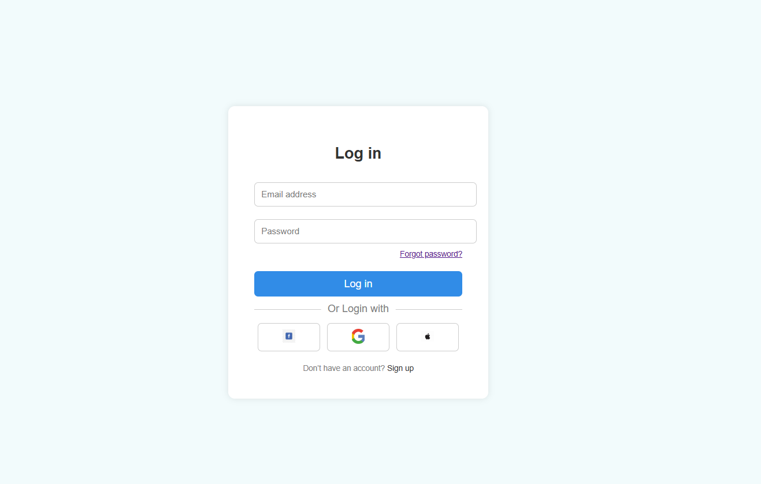

Forget password
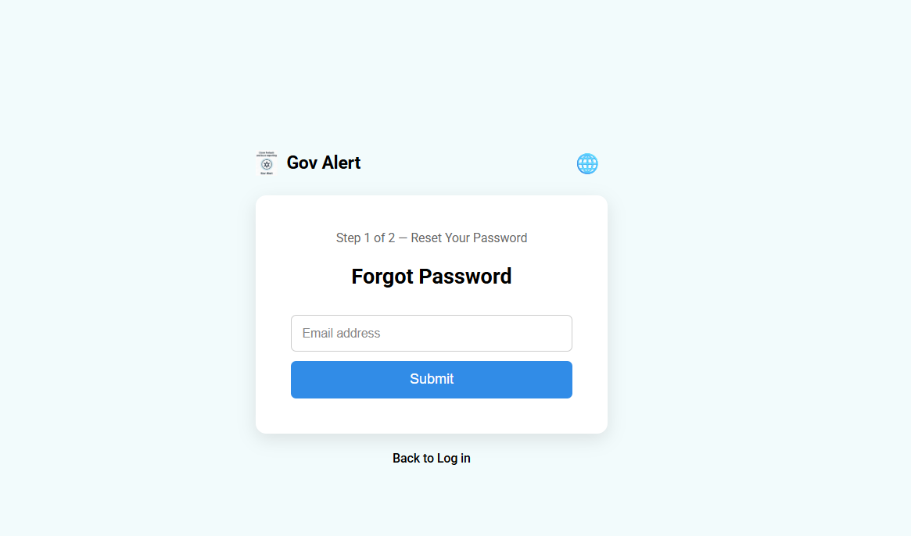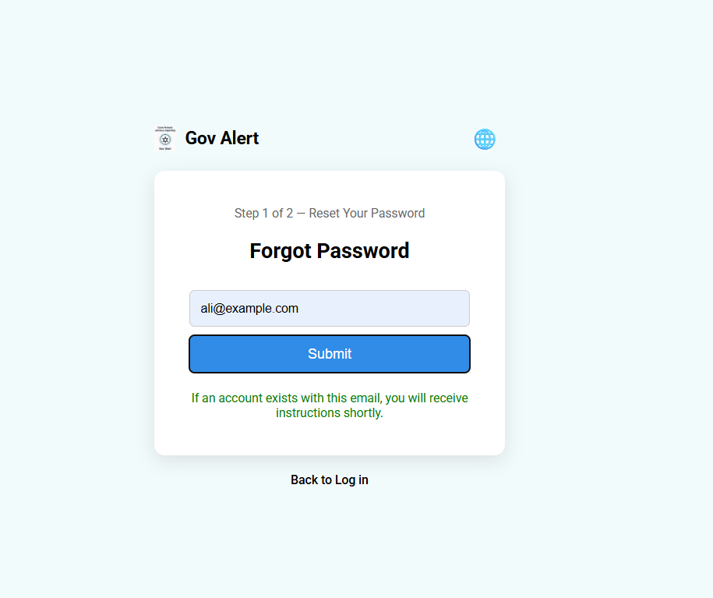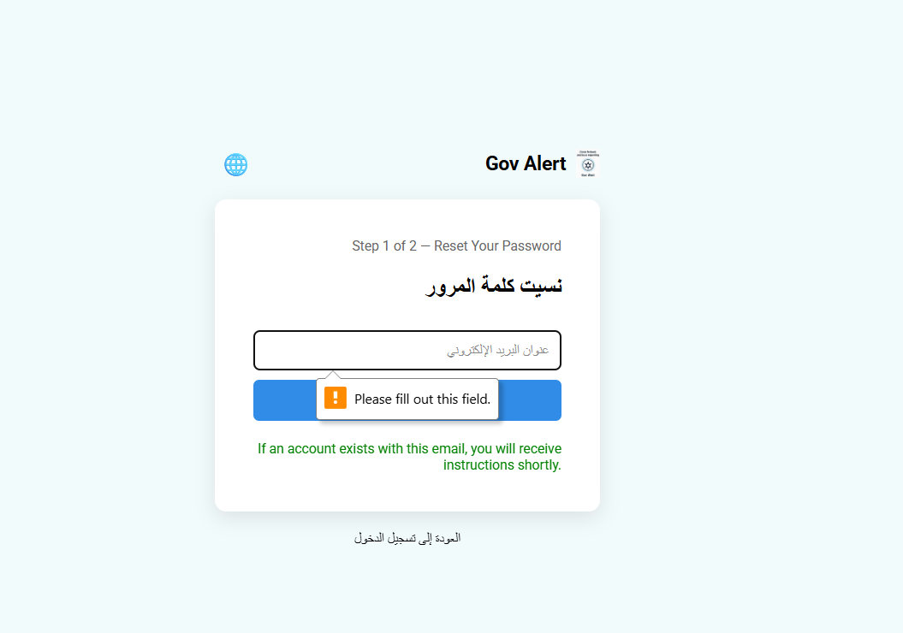

Sign up
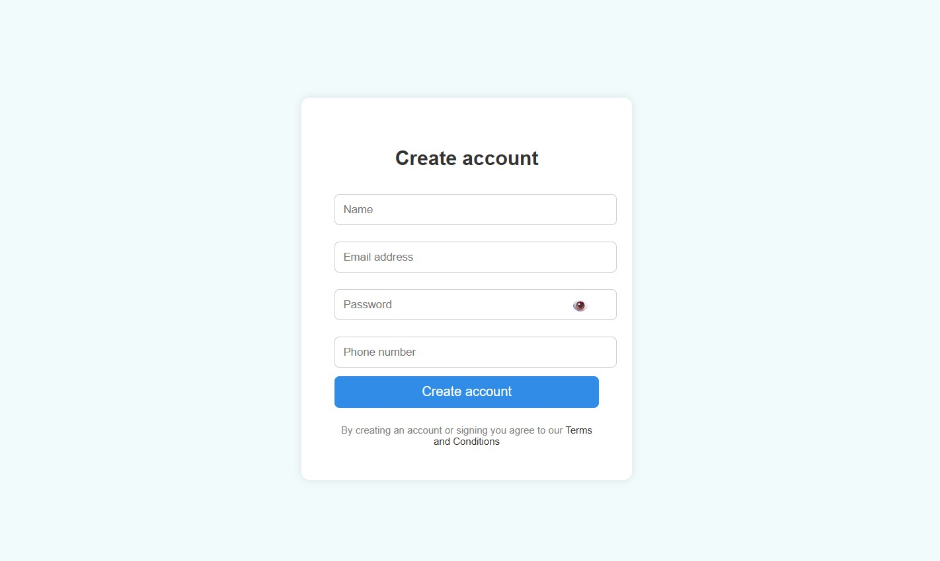

Citizen profile
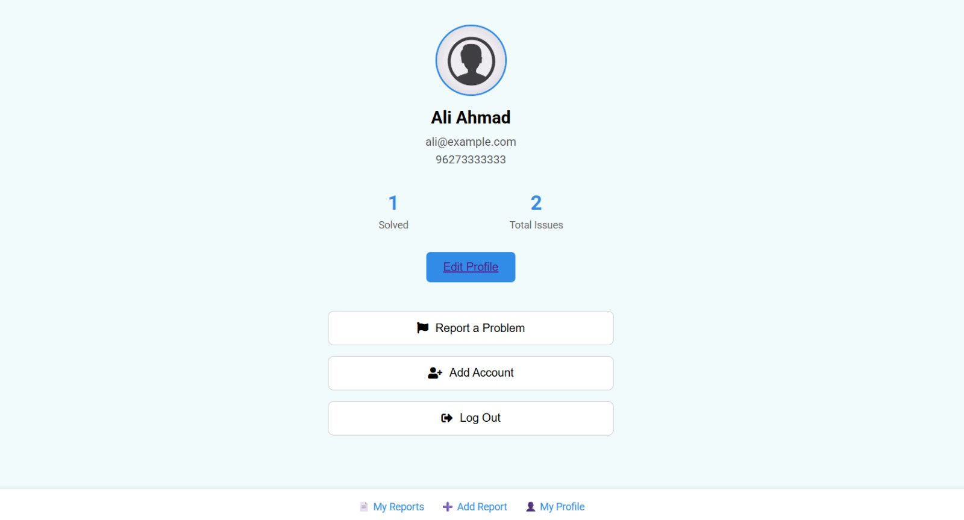

Edit profile

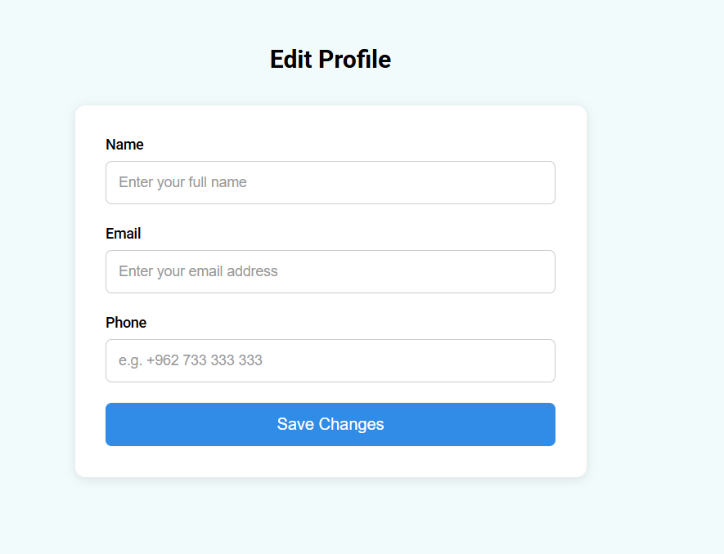

My report
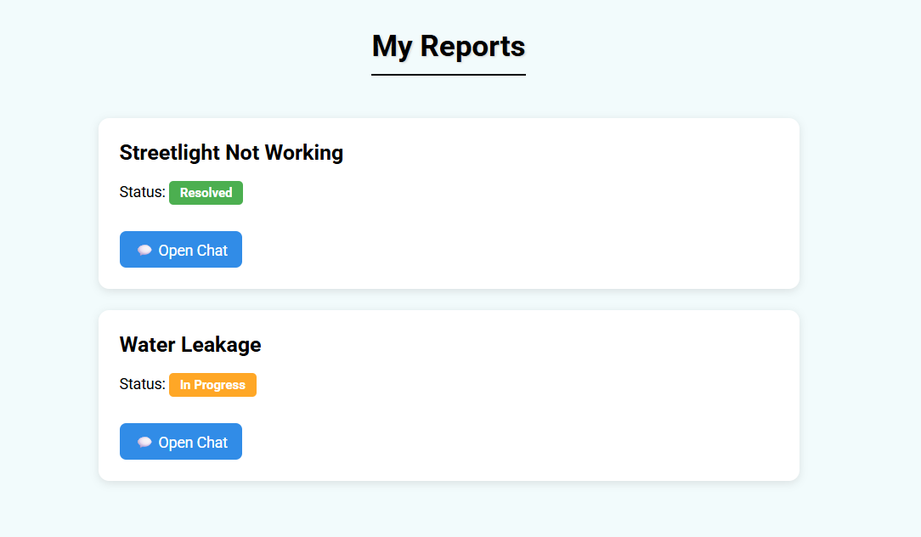

Add report
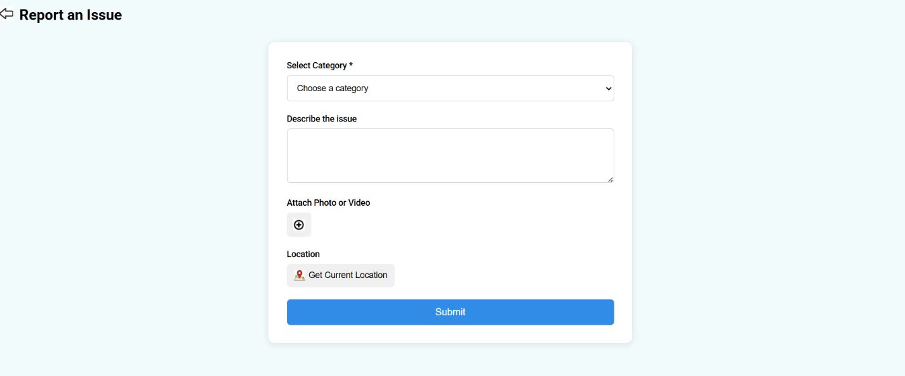

Chat overview
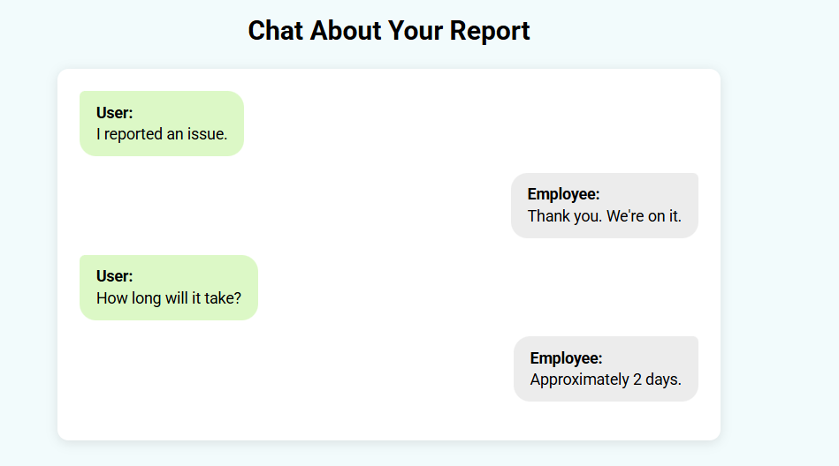

Terms and conditions
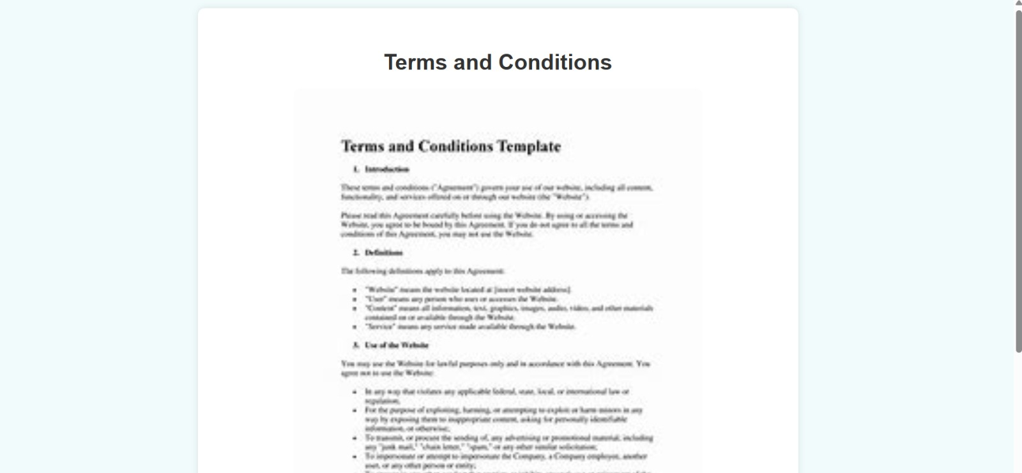

Government Department

Log in
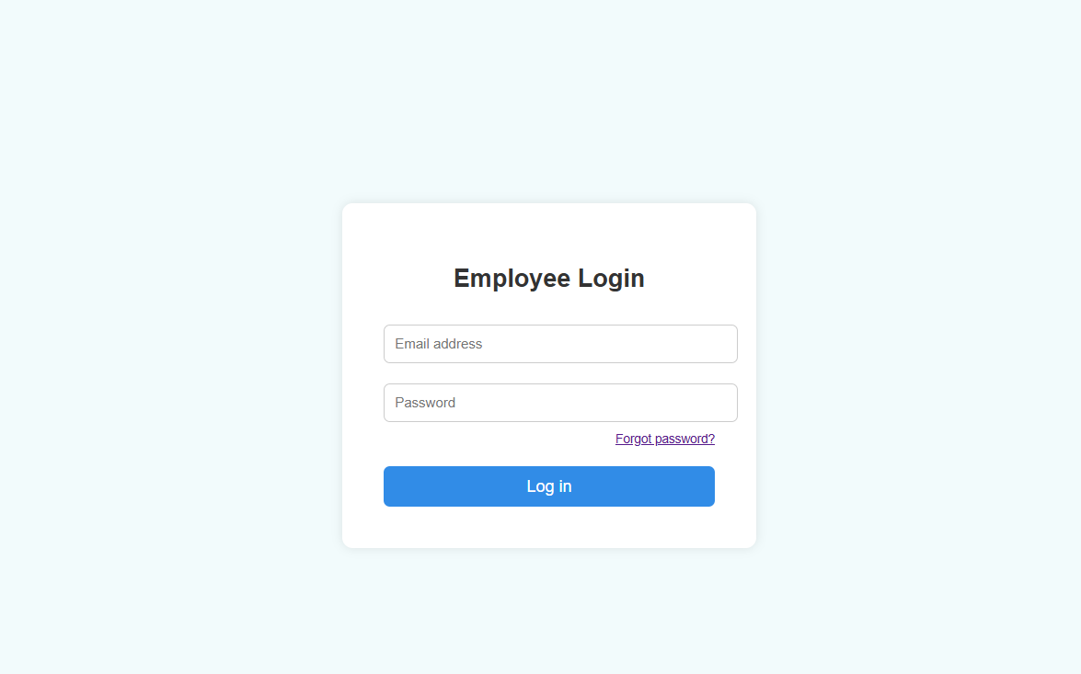

Forget password


My profile
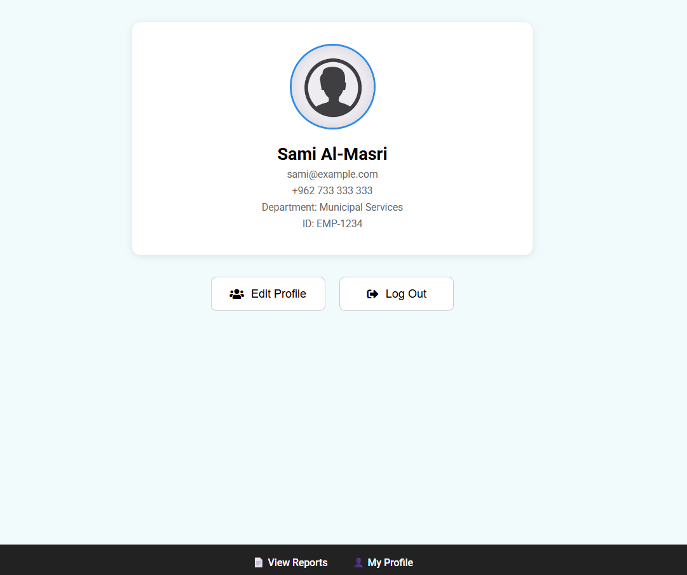

Edit profile



Report overview
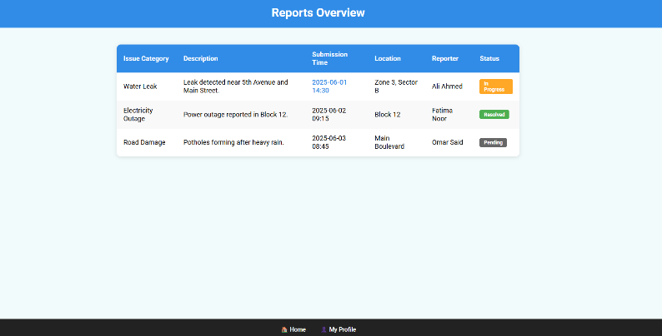

Report details
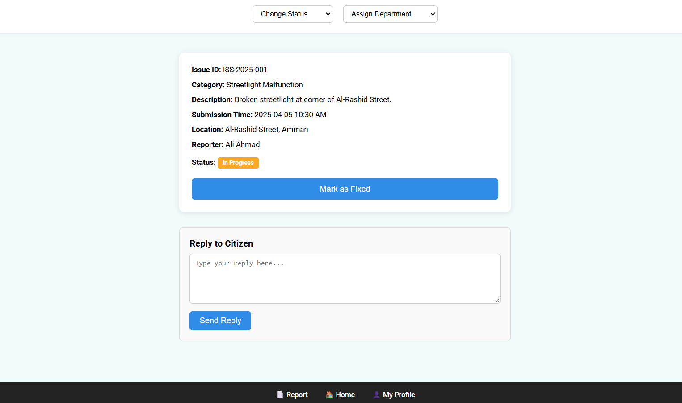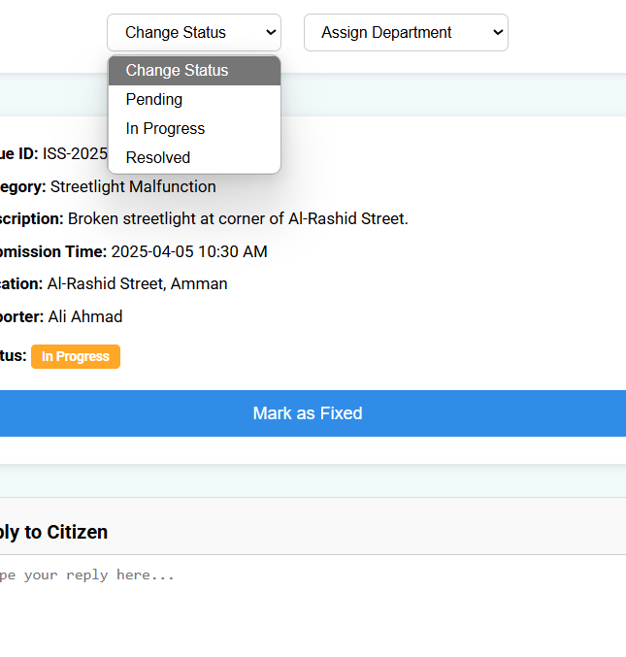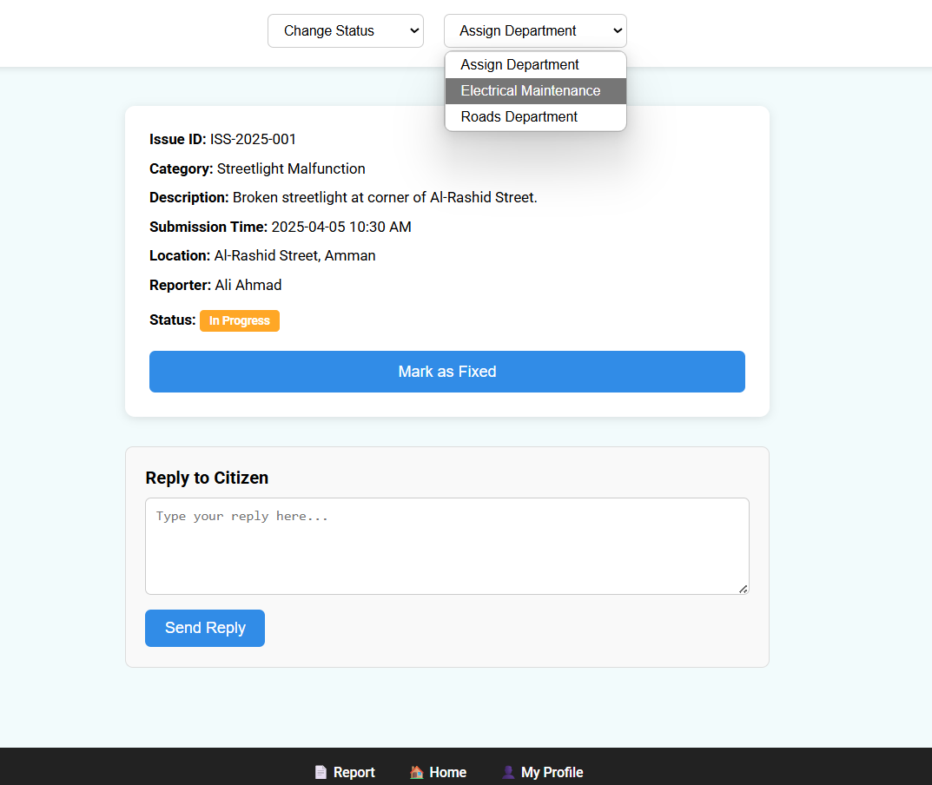

Database Implementation
Figure 10 User table
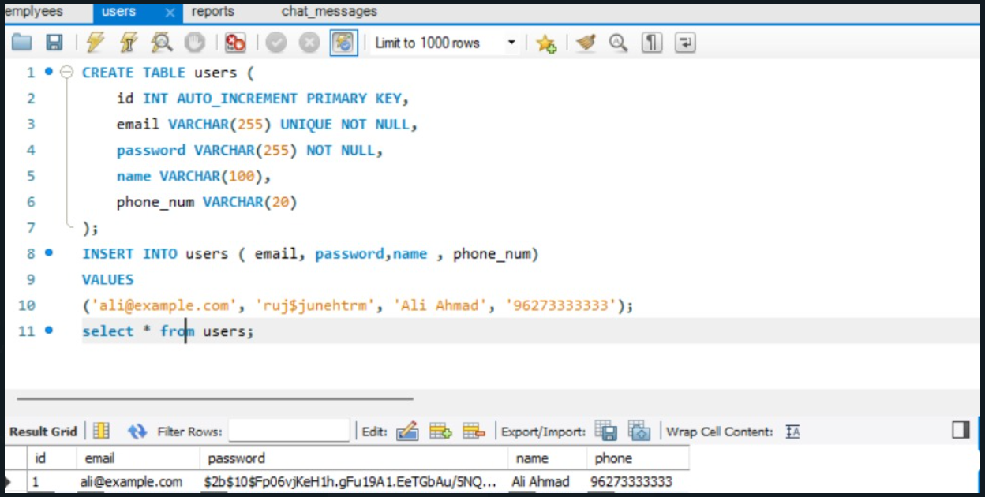
Figure 11 government department table
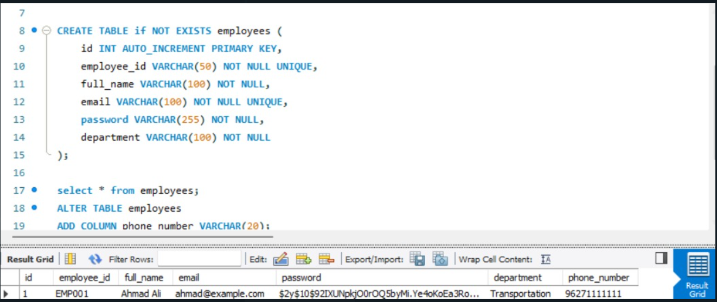
Figure 12 Report table
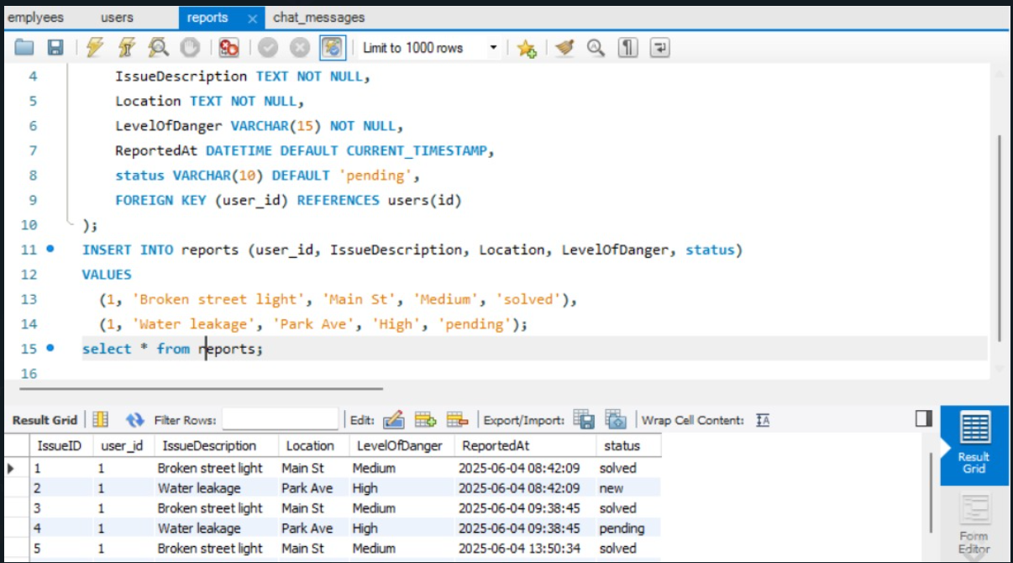
Figure 13 Chat table
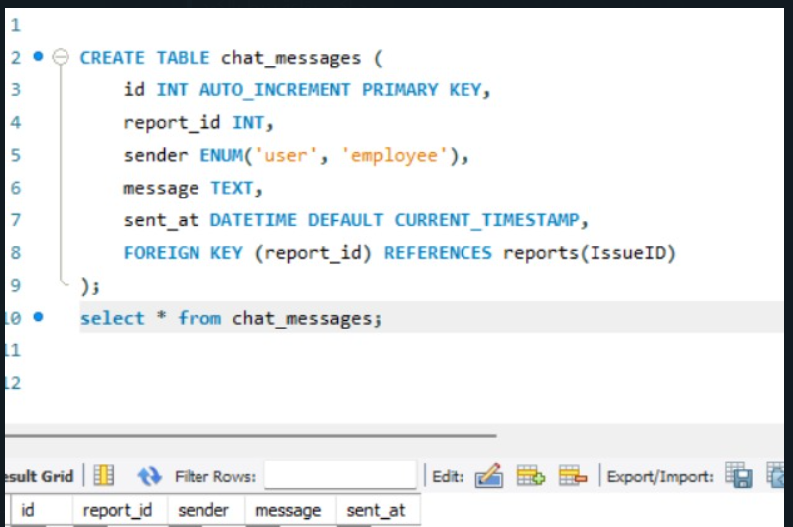

6.0 User Manual

How does it work?



STEP 1: Initiate Access

From the Home Screen, select:
• "Report an Issue" – to submit a new report.

You will automatically be redirected to the Login Screen if you're not logged in.

STEP 2: The LOG IN Screen

You'll see the following options:
• Email Address field
• Password field
• LOG IN button
• Forgot Password? link



To log in:
1. Tap the Email Address field and enter your registered email.
2. Tap the Password field and enter your password.
3. Tap the LOG IN button.

If you've forgotten your password:



1.Tap the Forgot Password?
2. Enter your registered email address.
3. Follow the reset instructions sent to your email inbox.
4. Return to the Sign In screen and use your new password to sign in.

STEP 3: For New Users



If you don’t have an account:

1. Tap SIGN UP At the bottom of the login screen.
2. Fill in the required fields:
- Name
- Email address
- Password
- Phone Number

3. Tap CREATE ACCOUNT.
4. You will be automatically logged in and redirected to the feature you were attempting to access.



STEP 4: For Reporting an issue

1.Access the Report Form

- From the profile page click “Report a problem”.
- The report submission screen will open.


2.Enter the Issue Details

Choose the Category:
- Tap the “Select Category” dropdown.
- Select the issue type

Describe the issue:
- In the “Describe the issue” box, provide clear details of the problem.

Attach Photos or Video:
- Click “+” to Upload Photos or videos for the issue

Provide Location Information:
- Click on “location” button and use the interactive map to mark the exact location.

Submit the Report:
- Click the “Submit” button.
- You’ll see a confirmation message once it’s submitted successfully

Step 5: View and Track Your Reports



1.From the bottom of your profile page, click “My Reports”, You’ll see a list of all issues you’ve submitted.

2.Each Report Displays:
- Title of the issue
- Status badge: ▪ Pending ▪ In Progress ▪ Resolved
- “Open in chat” button, to chat about your issue with the Employee.



Step 6: Edit Profile

1.From the bottom of your profile page, click “Edit Profile”.

2. Fill in the required fields:
- Name
- Email
- Phone

3. Click the “Save change” button.


Step 7: Log out

When you have finished raising your issue, from your profile page, click “Log Out” button to exit the website.

References
1.The course 1902372 lectures
2.The Book: Software-Engineering-9th-Edition-by-Ian-Sommerville
3.Past database course experiences.

4. https://www.tylertech.com/products/my-civic

